BOTSv3 Incident Analysis Report (AWS 200-Level Q1–Q8) — Frothly Corporation

1. Introduction

1.1 Context and Operational Environment
The Security Operations Centre (SOC) is the enterprise hub for monitoring, detection, and response to cyber threats (Vielberth et al., 2020). This report documents a forensic investigation into a security incident at Frothly Corporation using the Boss of the SOC (BOTSv3) dataset. The scenario reflects the operational challenge of maintaining visibility across hybrid and cloud estates (Cloud Security Alliance, 2021).

1.2 The BOTSv3 Exercise
The investigation uses BOTSv3’s high-fidelity telemetry to emulate live SOC conditions (Splunk, 2020). Rather than static training data, the analyst must separate legitimate administrative activity from adversarial Tactics, Techniques, and Procedures (TTPs). This mirrors Tier 2 investigation work, where interpretation and context are as important as raw log volume.

1.3 Objectives and Scope
The objective is to demonstrate a defensible investigative workflow by answering the AWS-focused 200-level questions (Q1–Q8). Using Splunk Search Processing Language (SPL), the analysis identifies IAM principals, isolates non-MFA API activity, and attributes S3 misconfigurations. Queries are designed to be repeatable, with explicit indexes and sourcetypes, preserving evidential integrity and enabling peer review plus dashboard operationalisation for later audit purposes. Findings are structured using the NIST incident response lifecycle to support root cause analysis (Cichonski et al., 2012).
Scope is limited to botsv3 events. Control-plane activity is prioritised via aws:cloudtrail, data-plane confirmation via aws:s3:accesslogs, and endpoint inventory via winhostmon. Written from a Tier 2 Incident Responder perspective, recommendations follow an “assumed breach” posture (SANS Institute, 2023).

2. SOC Roles & Incident Handling Reflection

2.1 SOC Operating Model and Tiered Responsibilities
For this investigation, a standard three-tier SOC model is assumed. The objective is converting raw telemetry into defensible evidence, ensuring timely escalation while minimising "alert fatigue" (Vielberth et al., 2020). The BOTSv3 dataset demonstrates that effective defence requires cross-functional competency (SANS Institute, 2023).
- Tier 1 (Monitoring & Triage): Validates high-volume signals (e.g., public S3 changes, non-MFA API spikes) and filters benign activity against approved change.
- Tier 2 (Incident Response): Correlates identity with data-plane impact, cross-checks endpoint logs for drift, and confirms scope and intent.
- Tier 3 (Threat Hunting & Engineering): Converts Tier 2 findings into durable detections, tuning logic to reduce noise and surface “Shadow IT”.

2.2 Incident Handling Workflow (NIST)
The workflow aligns with NIST SP 800-61 Rev. 2 (Cichonski et al., 2012):
- Preparation: Centralised CloudTrail and WinHostMon telemetry.
- Detection & Analysis: Validation, scoping, and TTP mapping (e.g., MITRE T1078) to build confidence.
- Containment: Revoke keys and enforce S3 “Block Public Access”.
- Eradication & Recovery: Remove unauthorised objects and isolate non-compliant endpoints for reimaging.
- Post-Incident: Implement SCP guardrails to prevent recurrence.

2.3 Escalation and Strategic Reflection
Escalation from Tier 1 to Tier 2 occurs once unauthorised activity is confirmed (e.g., public access change plus upload evidence). The incident shows over-reliance on detection for high-risk cloud actions. Prevention is required: platform-level SCPs enforcing Multi-Factor Authentication (MFA) would reduce credential abuse at source, and shared accounts should be removed to restore non-repudiation. In cloud environments, identity is the perimeter; traditional network controls offer limited visibility into configuration changes (Cloud Security Alliance, 2021).

3. Installation & Data Preparation
To complete this report Splunk Splunk Enterprise (v10.0.2) was installed on a Linux workstation. The installation followed standard Linux administration conventions by deploying the software to the /opt/splunk directory. This location is operationally preferred for third-party applications as it isolates the Splunk binaries and indexes from the host's root filesystem The service was initialised via the CLI command $SPLUNK_HOME/bin/splunk start, and while production SOCs utilise distributed architectures for scalability, a standalone design was selected here to prioritise forensic isolation and data stability (Vielberth et al., 2020).
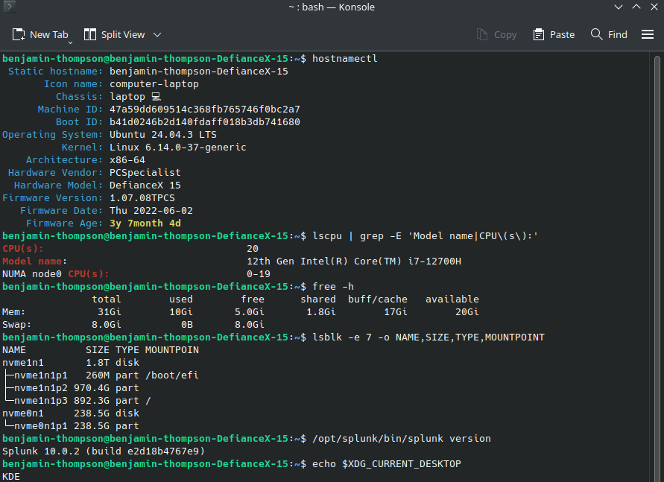Figure 1
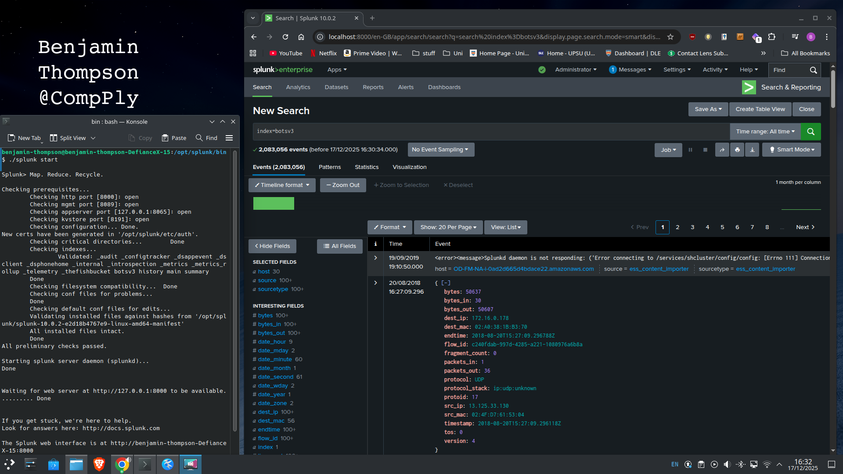Figure 2
The BOTSv3 dataset was obtained from GitHub using the “botsv3” repository the download was verified by confirming the archive size, validating successful extraction without errors, and checking that the extracted directory structure contained the expected files prior to ingestion. Ingestion began by manually installing the botsv3_data_set application into /opt/splunk/etc/apps/. This step applies the props.conf settings required for Common Information Model (CIM) compliance, enabling the normalisation of raw JSON fields (e.g., userIdentity) for cross-domain correlation. The dataset was then extracted locally and ingested via a monitored directory input to ensure a static, repeatable path distinct from live network feeds.

Index Management and Governance
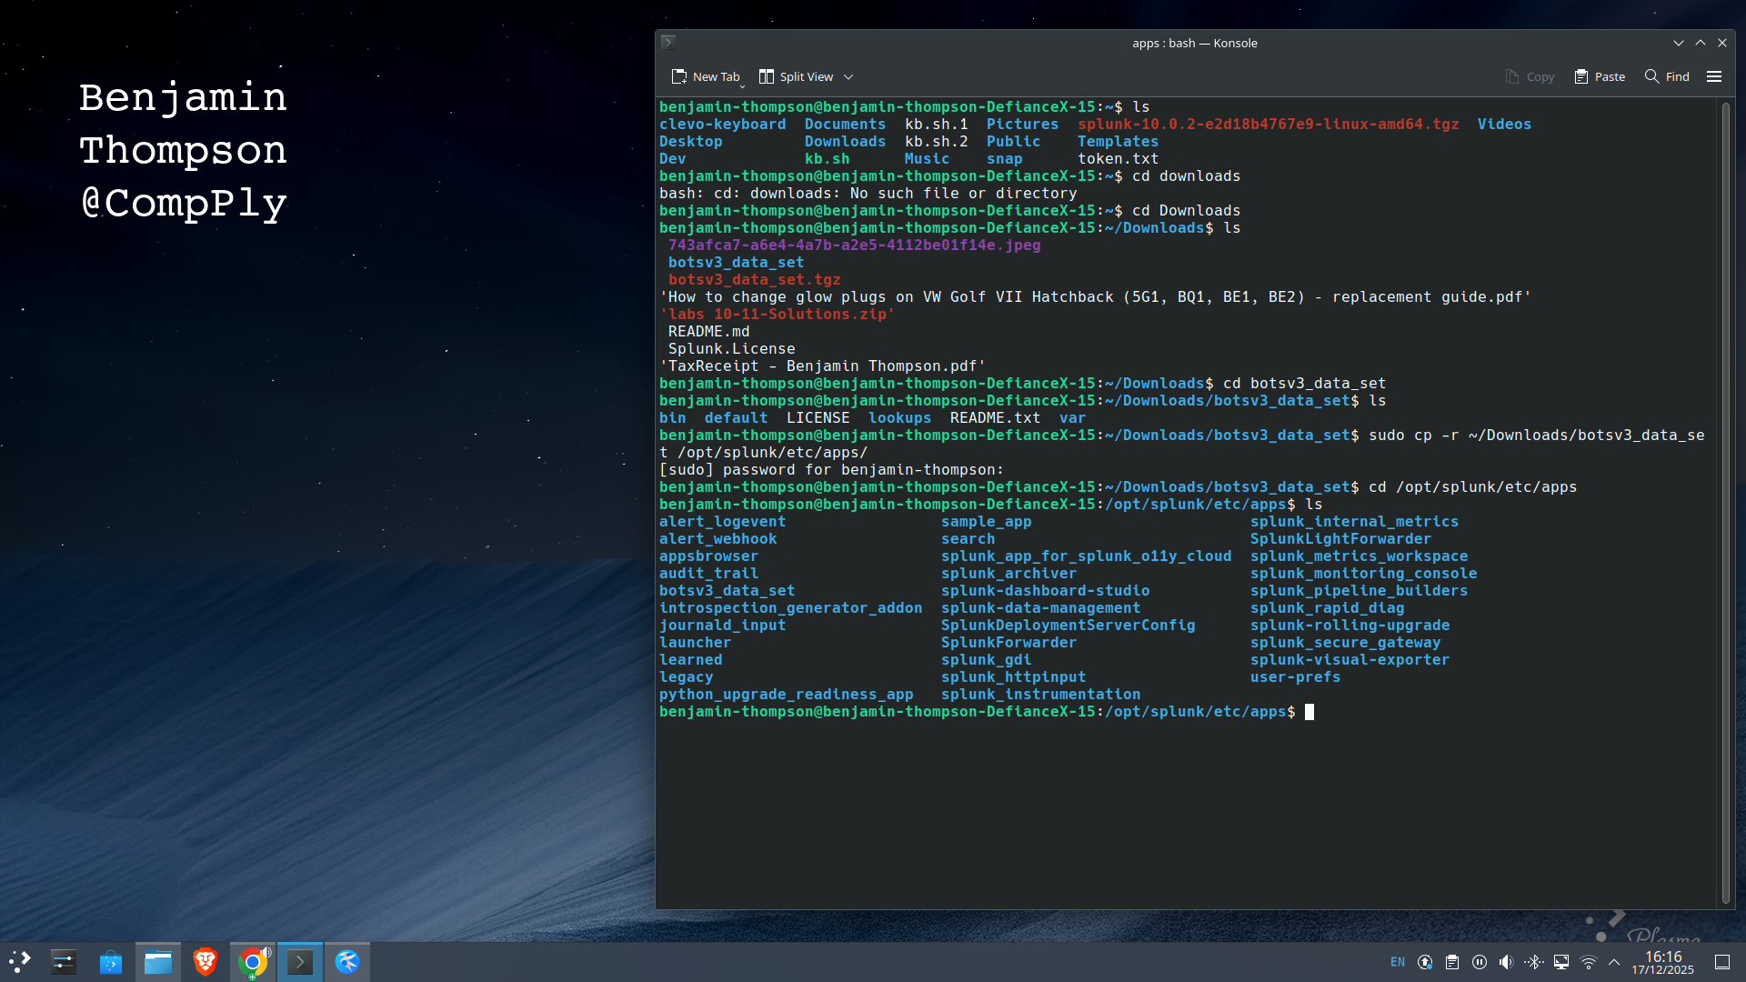Figure 3
Data was directed to a dedicated botsv3 index rather than the default main. In an operational context, this segmentation enforces Data Governance, allowing for granular Retention Policies and Role-Based Access Control (RBAC) to protect sensitive evidence (ISACA, 2019). Post-ingestion validation using tstats confirmed a total volume of 1,944,092 events, establishing a defensible evidentiality baseline.
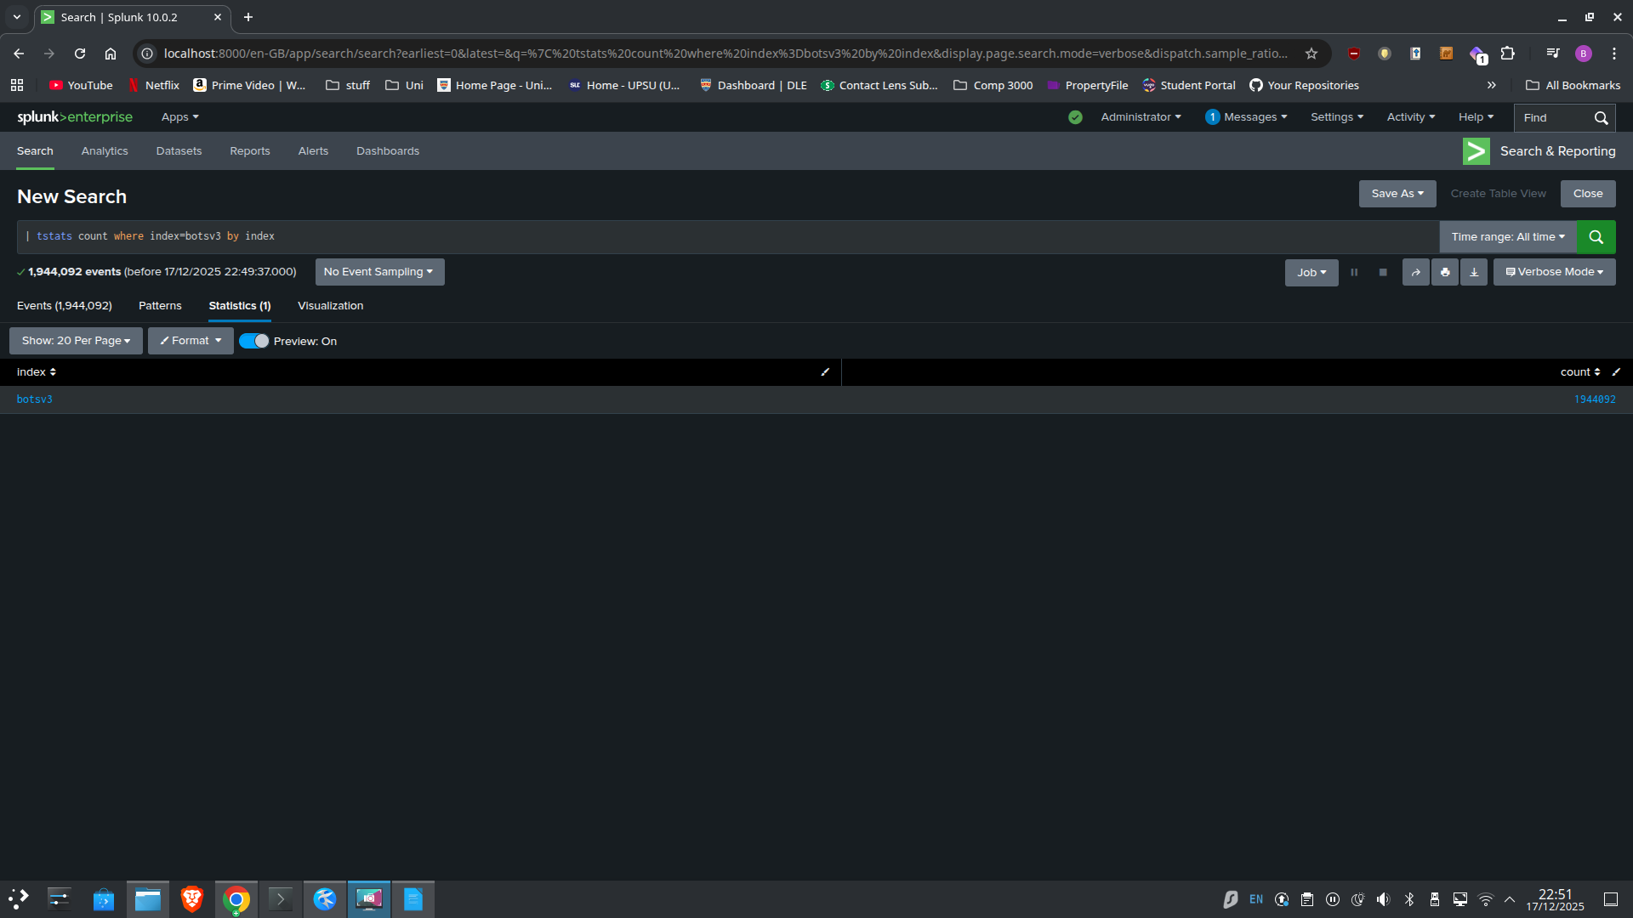Figure 4

4.0 Analytical Methodology
To reconstruct the incident effectively, the investigation applied a hypothesis-driven methodology to the botsv3 dataset (Lee and Bianco, 2016). A "Funnel of Fidelity" approach was utilised to manage alert volume: initiating with broad searches across key sourcetypes (aws:cloudtrail, winhostmon) to establish a baseline, then iteratively filtering by high-fidelity indicators, such as specific Event IDs and User Agents, to isolate the attack vector (Atkinson, 2019).

4.1 Question 1: Identification of IAM Users
To identify the IAM (Identity & Access Management) users accessing AWS services within Frothly’s environment. CloudTrail provides authoritative audit records of AWS control-plane activity, the investigation first confirmed the presence of CloudTrail telemetry using a metadata search (| metadata type=sourcetypes index=botsv3 | stats values(sourcetype)).
Inspecting user-related fields within the aws:cloudtrail sourcetype confirmed that the field userIdentity.type="IAMUser" reliably distinguishes named IAM principals from other identity categories such as assumed roles.
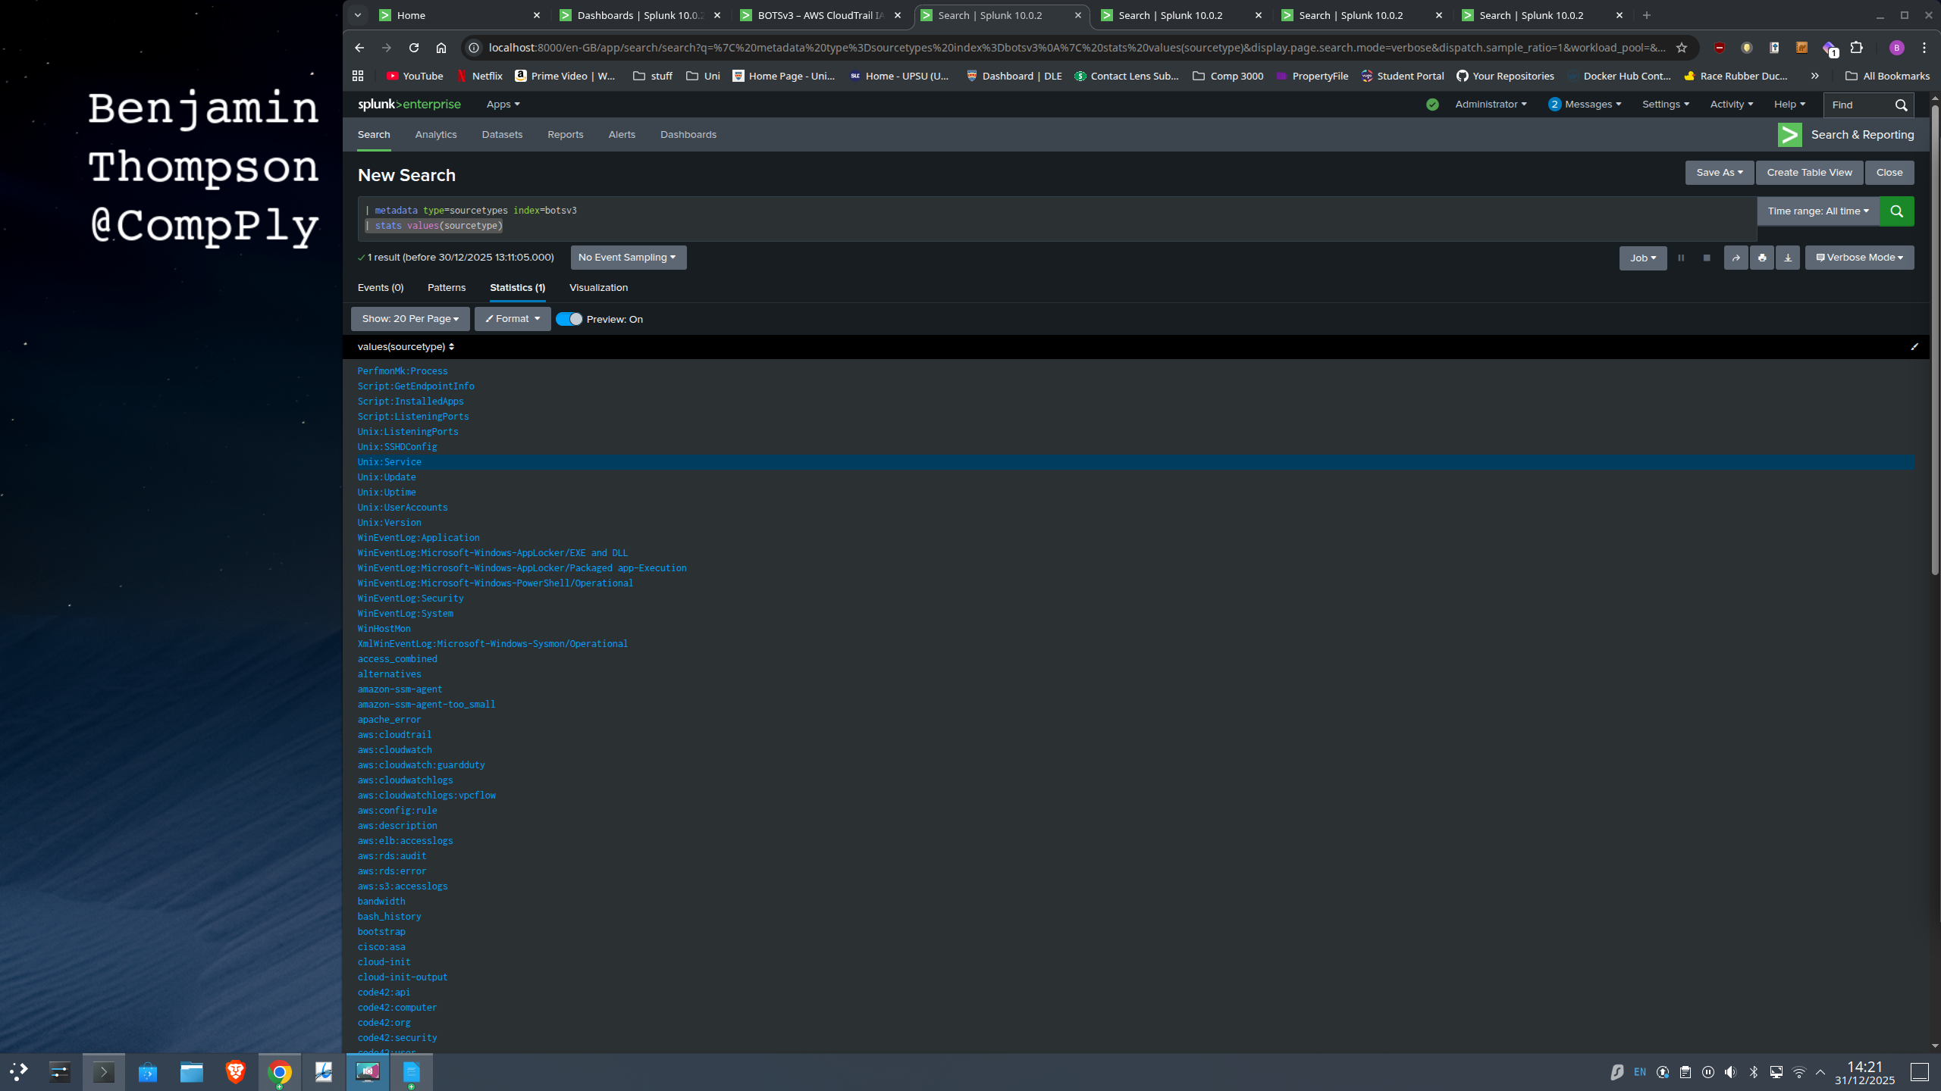Figure 5
On this basis, the final aggregation query was executed:
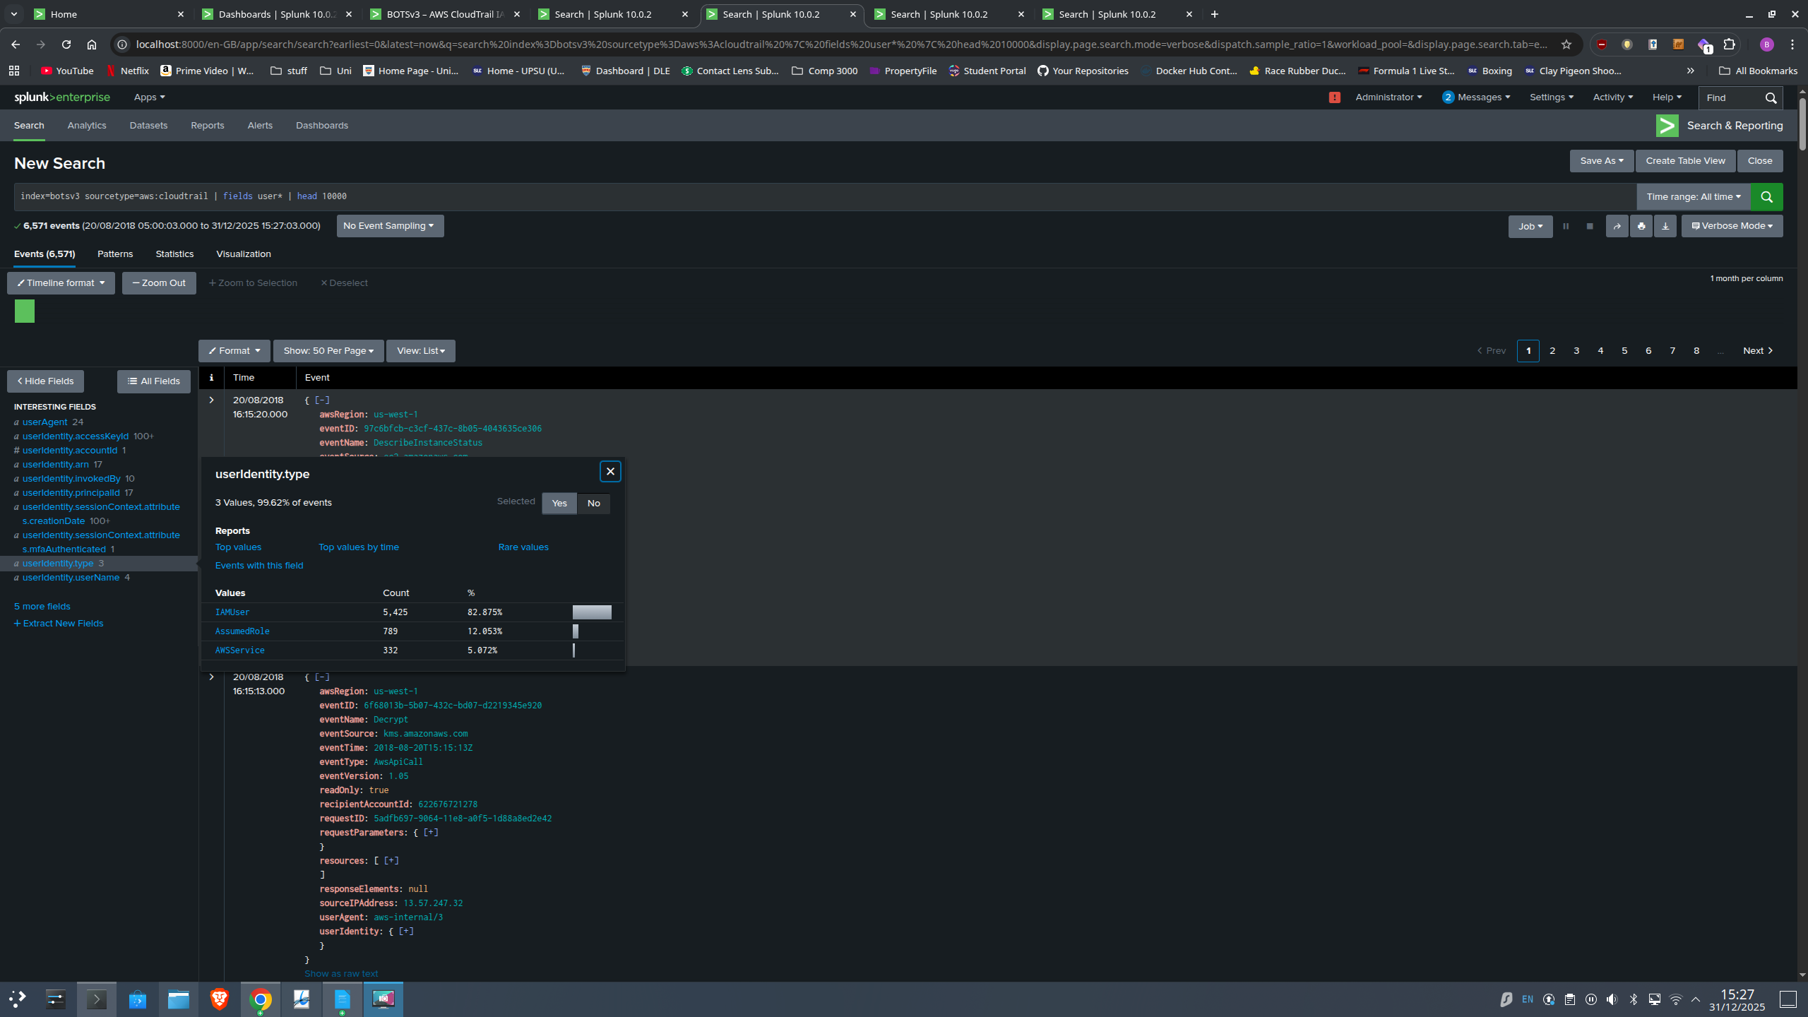Figure 6
index=botsv3 sourcetype=aws:cloudtrail "userIdentity.type"=IAMUser
| stats count by userIdentity.userName
The results definitively identified four IAM users: bstoll, btun, splunk_access, and web_admin.
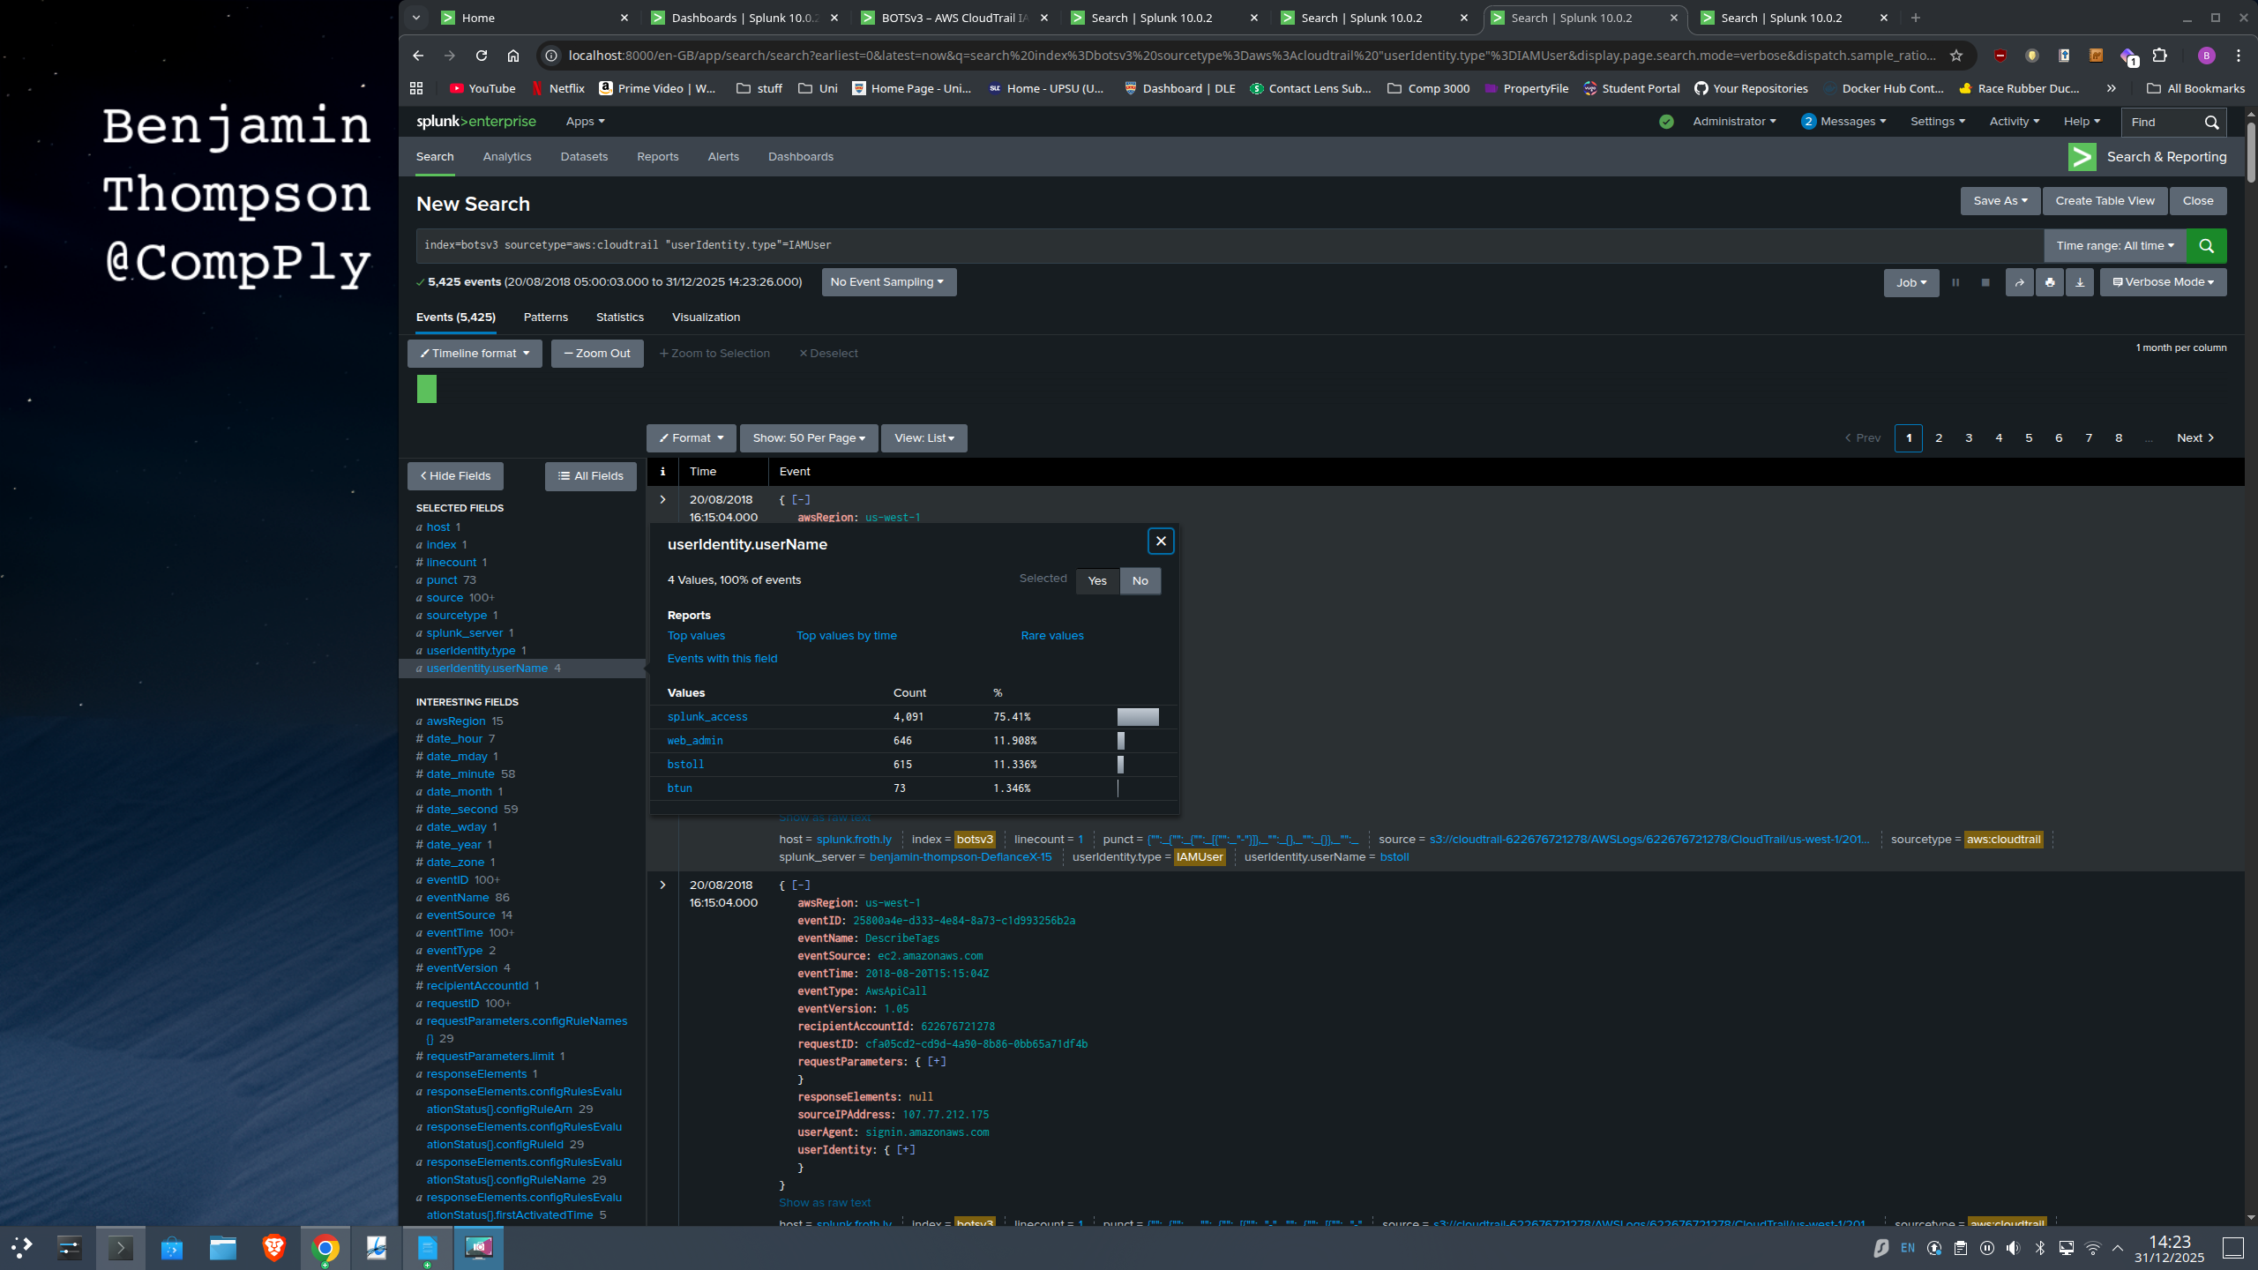Figure 7
These IAM users were also put into a dashboard so future actions can be monitored seen below.
From a Security Operations Centre (SOC) perspective, an IAM identity baseline is a vital detection tool. Tier 1 analysts rely on this baseline to flag clear anomalies, such as a user connecting from a suspiciously high number of unique IP addresses. If such activity cannot be verified, the standard protocol involves escalating to cloud administrators to disable access keys. Furthermore, the discovery of shared accounts like web_admin reveals a governance gap. To restore accountability, Security Engineering must replace generic logins with named accounts and enforce Multi-Factor Authentication (MFA) to prevent recurrence.
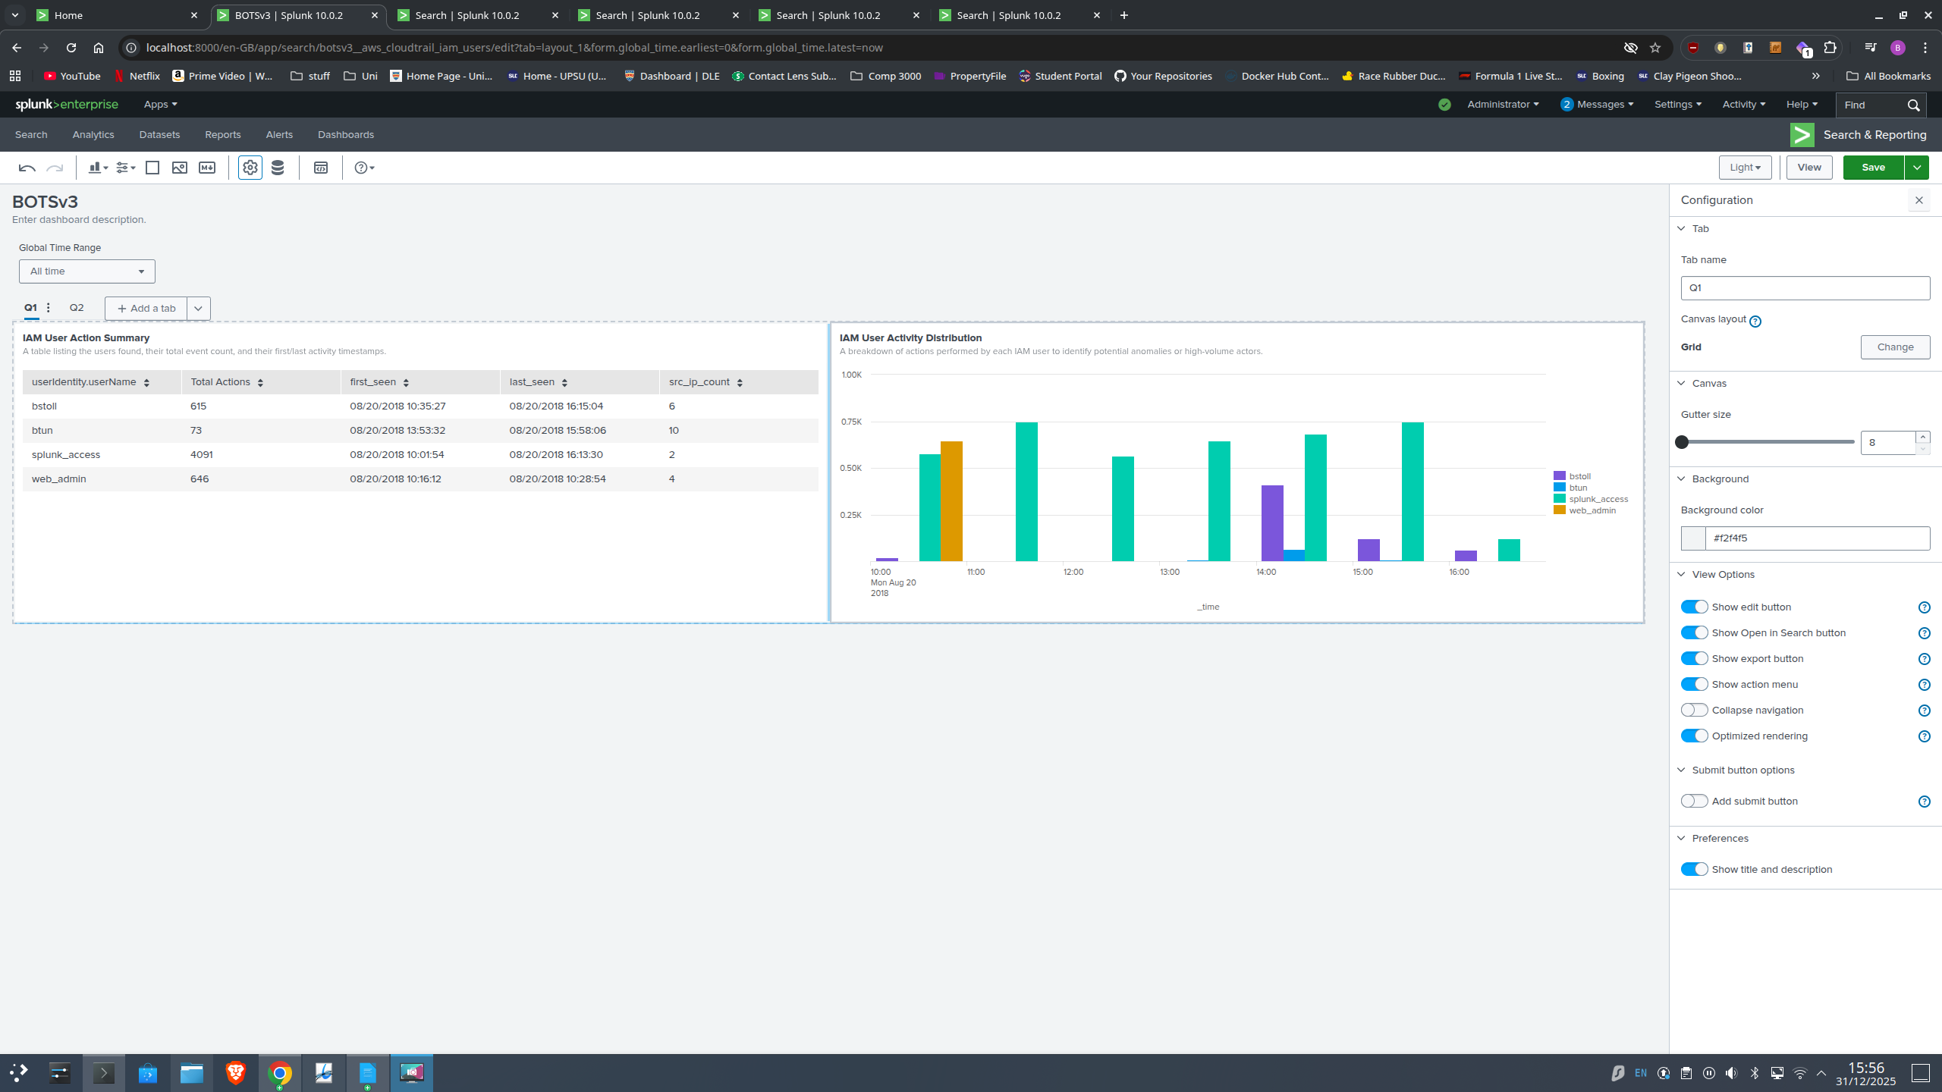Figure 8

4.2 Question 2: Alerting on Non-MFA API Activity
The objective was to identify the CloudTrail field that evidences AWS API activity occurring without Multi-Factor Authentication (MFA), while excluding console logins. As console authentication and programmatic API authentication are represented differently, the analysis was restricted tp:
index=botsv3 sourcetype=aws:cloudtrail NOT eventName=ConsoleLogin
Inspection of the event schema revealed the candidate field “userIdentity.sessionContext.attributes.mfaAuthenticated”. A comparative statistical analysis validated this field as the definitive indicator for API calls.
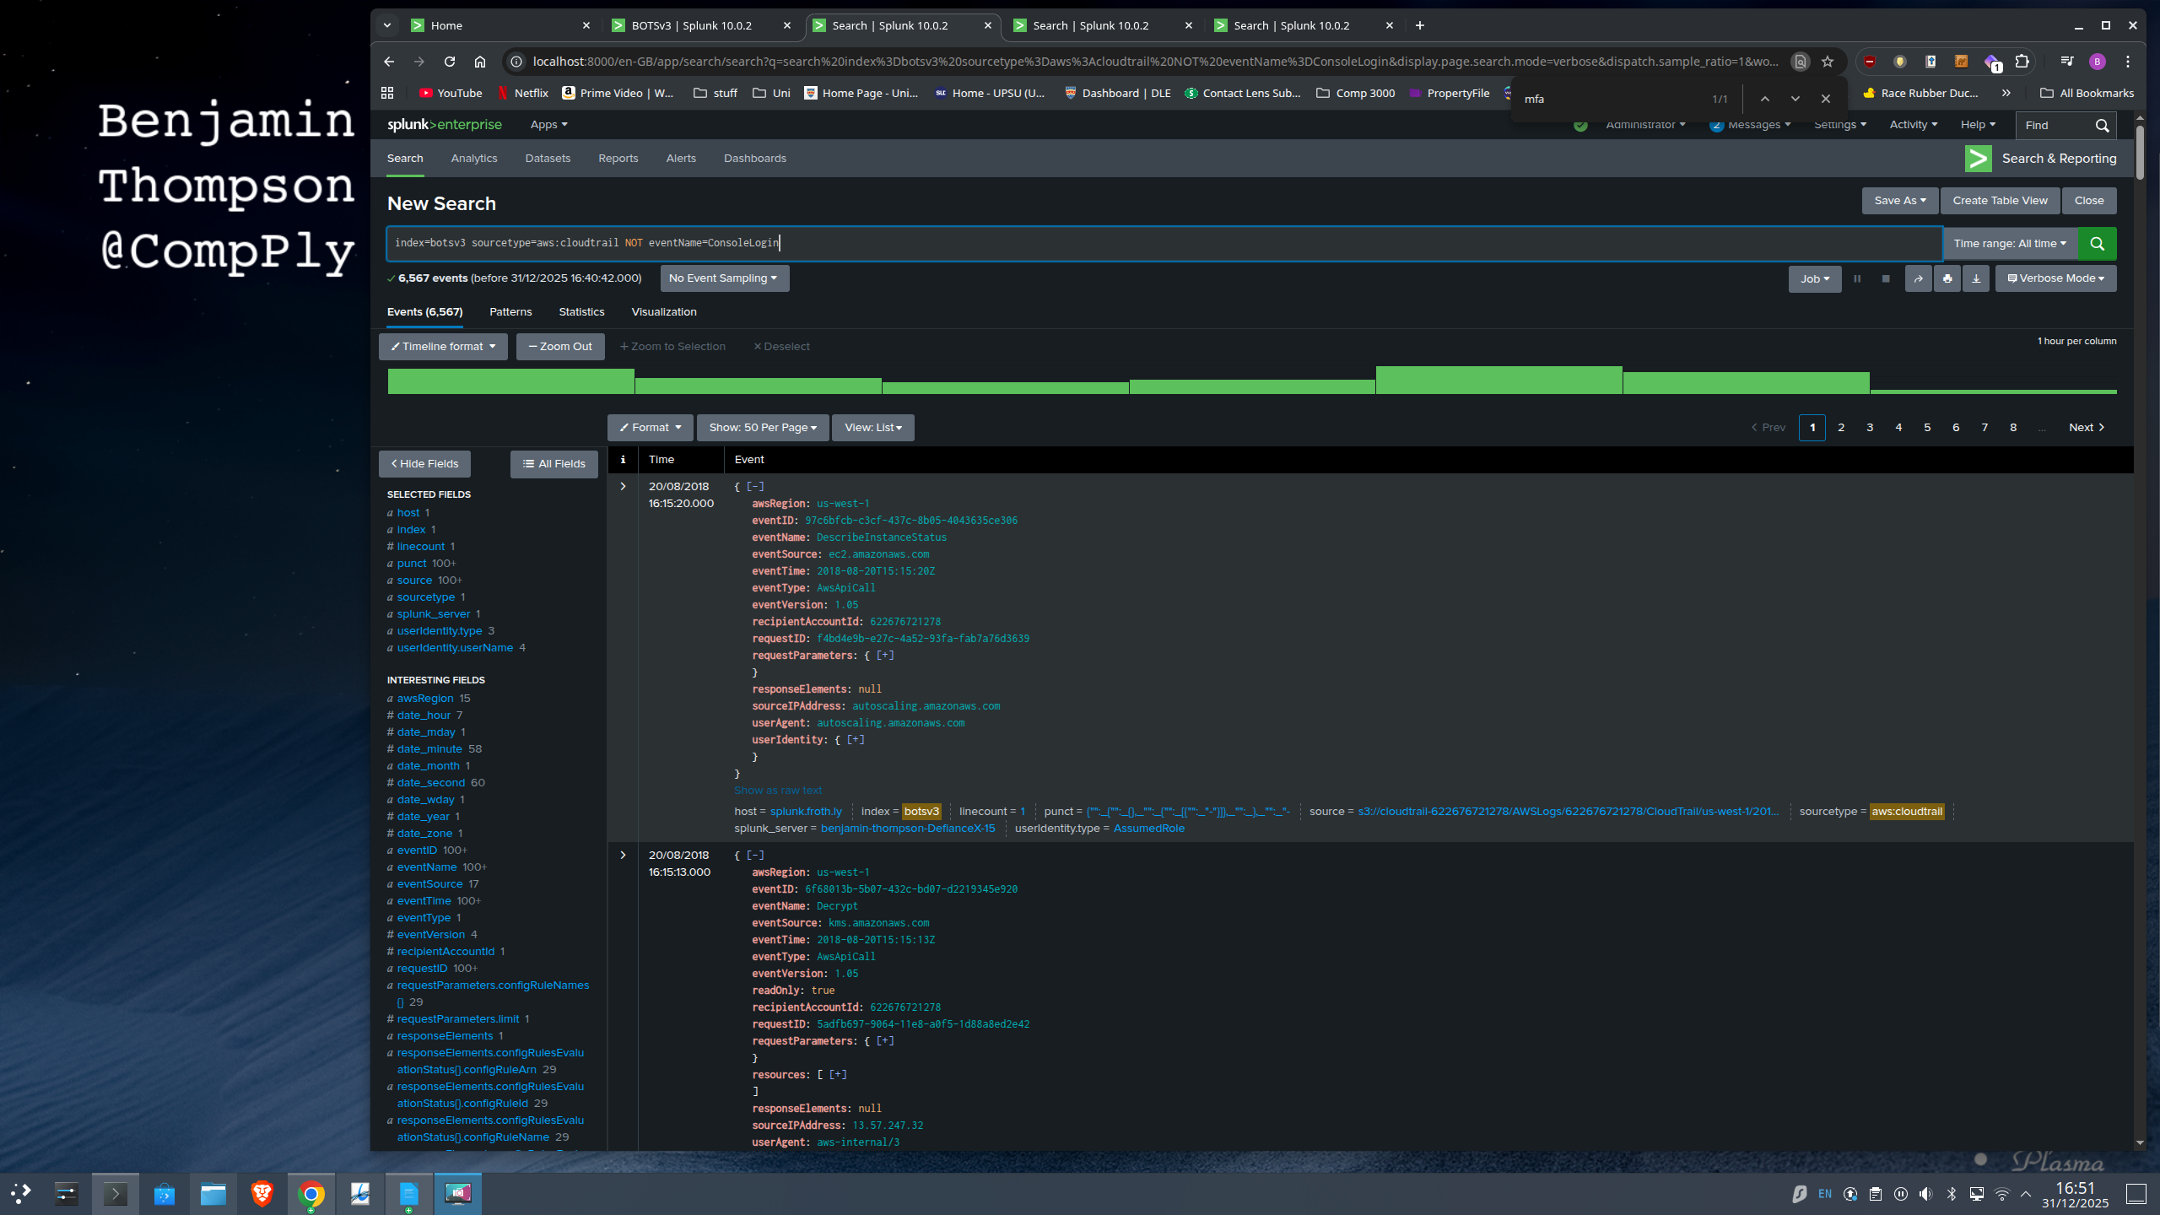Figure 9
index=botsv3 sourcetype=aws:cloudtrail NOT eventName=ConsoleLogin "userIdentity.sessionContext.attributes.mfaAuthenticated"="*"
To operationalise this, the logic was built into a dashboard panel summarising API calls by principal and MFA state. This enabled rapid verification that the field is consistently populated for relevant API events and that it differentiates MFA-authenticated and non-MFA sessions in a manner appropriate for SOC monitoring.
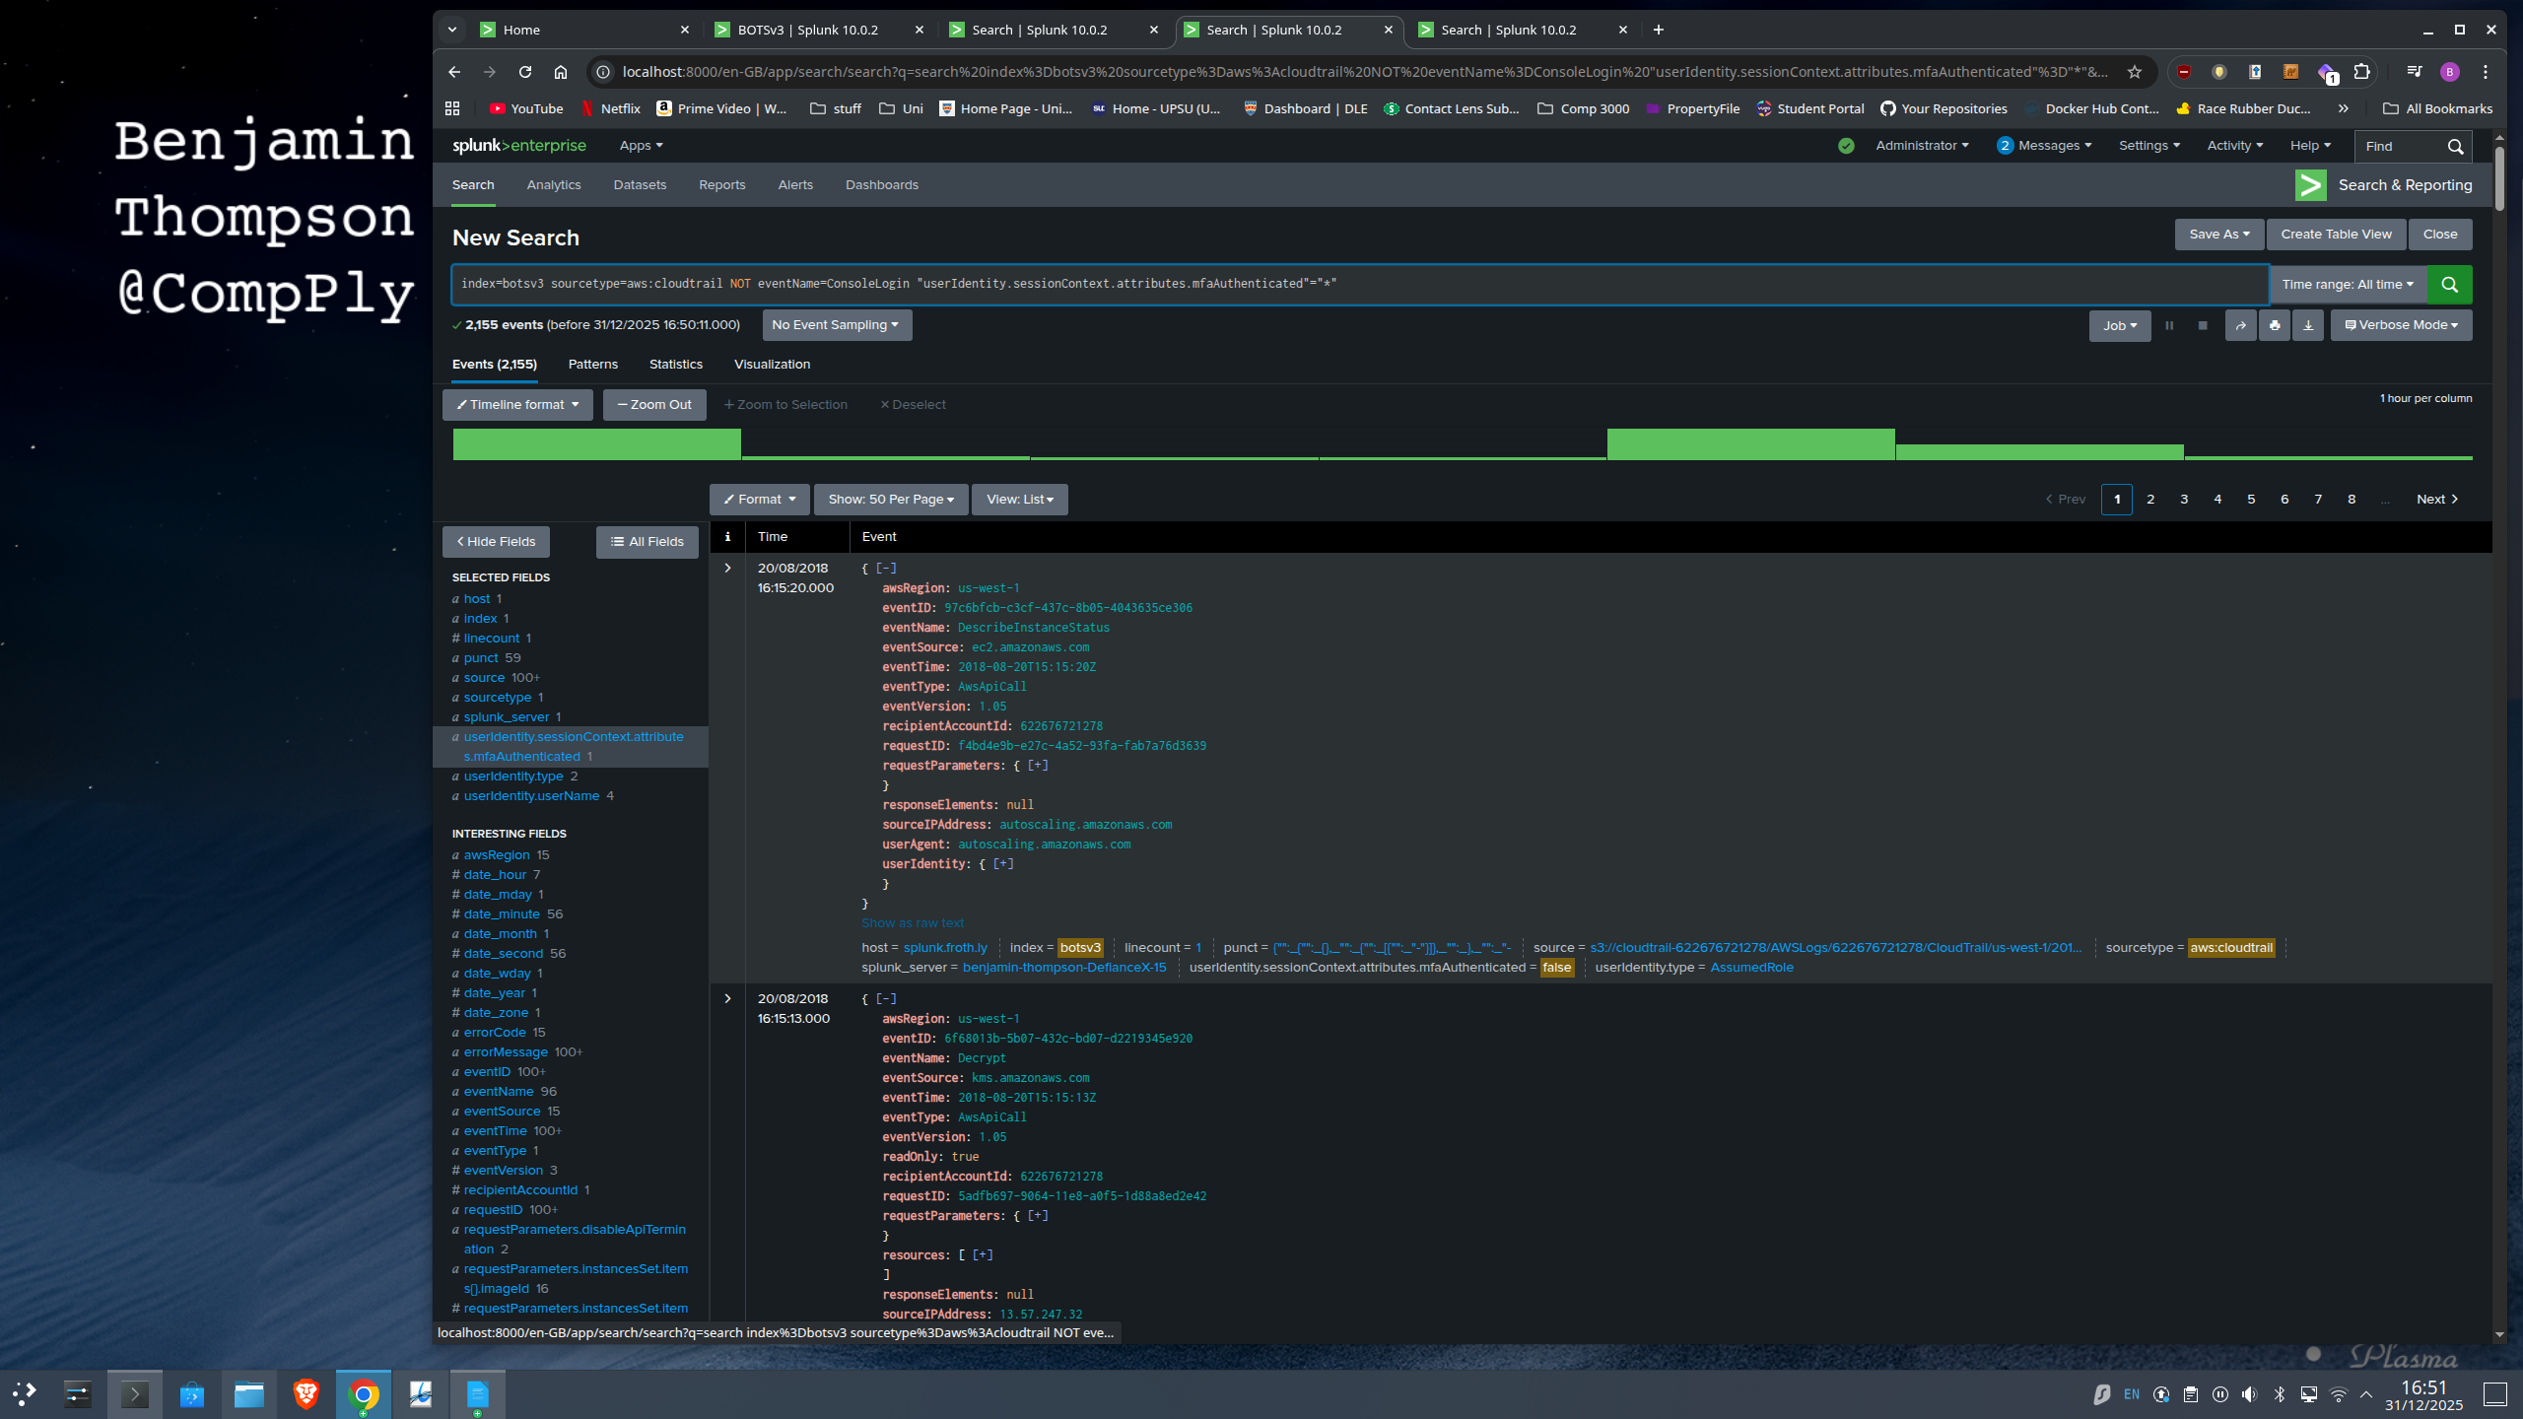Figure 10
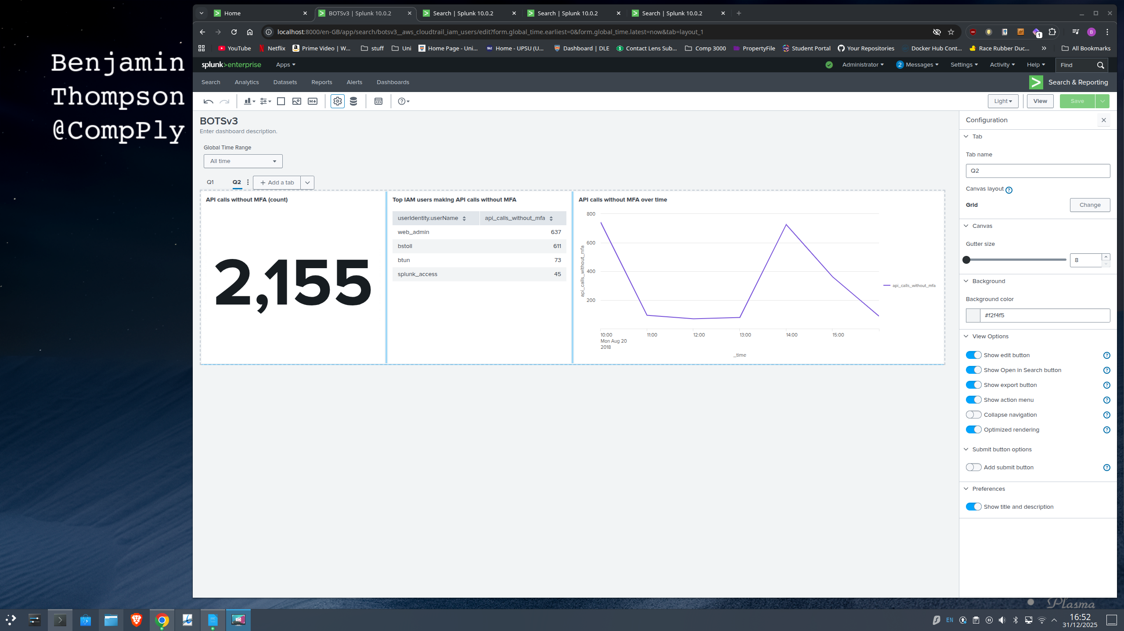Figure 11

From a SOC perspective, non-MFA API activity is a useful indicator of weak authentication controls and potential credential misuse. Tier 1 can use this view to spot and report policy breaches, such as the 2,155 API calls executed without MFA in this dataset. Tier 2 should then validate whether the behaviour is expected. In this case, the volume attributed to web_admin and bstoll is particularly concerning, as it suggests privileged or shared access operating without a second factor. The longer-term fix should sit with security engineering: move beyond detection by enforcing MFA at the platform level (for example, an SCP using the aws:MultiFactorAuthPresent condition) so privileged API requests are denied when MFA is not present.

4.3 Question 3: Web Server Processor Inventory
Identifying the processor number supports asset inventory and baseline validation as well as accurate asset inventory. By scoping out the the hardware inventory using: index=botsv3 sourcetype="hardware" which returns host-level key–value attributes for system components as shown in Figure 12. Inspection of the CPU_TYPE field within these records showed the processor consistently reported as Intel(R) Xeon(R) CPU E5-2676 v3 @ 2.40GHz. Which allows us to idenify the processer number as E5-2676.
From a SOC perspective, accurate hardware inventory is essential. Tier 1 and 2 analysts rely on this data to spot "Shadow IT" if the physical hardware doesn't match the authorized database, it triggers an immediate investigation. At a strategic Tier 3 level, knowing the exact processor model is vital for vulnerability management. Hardware-level threats like Spectre or Meltdown target specific CPU architectures and without a precise inventory, the SOC analists cannot determine which machines are exposed to these risks.
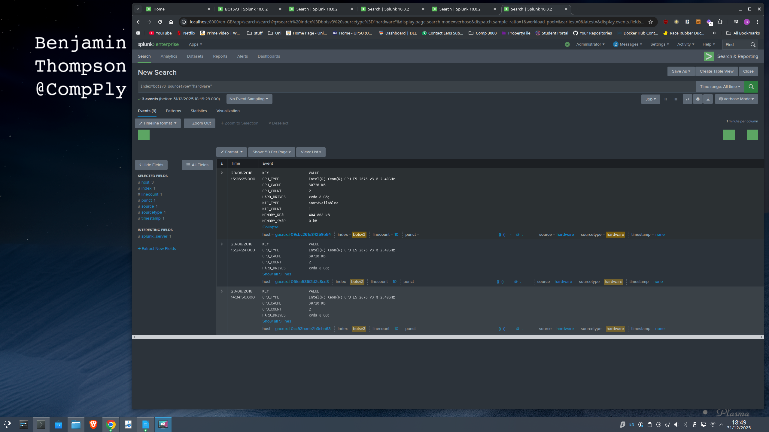Figure 12

4.4 Question 4: S3 Bucket Public Access Identification
The investigation analysed aws:cloudtrail logs for control-plane modifications. An initial search using “bucket” identified PutBucketAcl as the specific API action used to alter permissions.
A targeted filter was applied “index=botsv3 sourcetype=aws:cloudtrail eventName=PutBucketAcl” to isolate this field revealed 2 events in which the Acl was changed to nothing allowing public access.
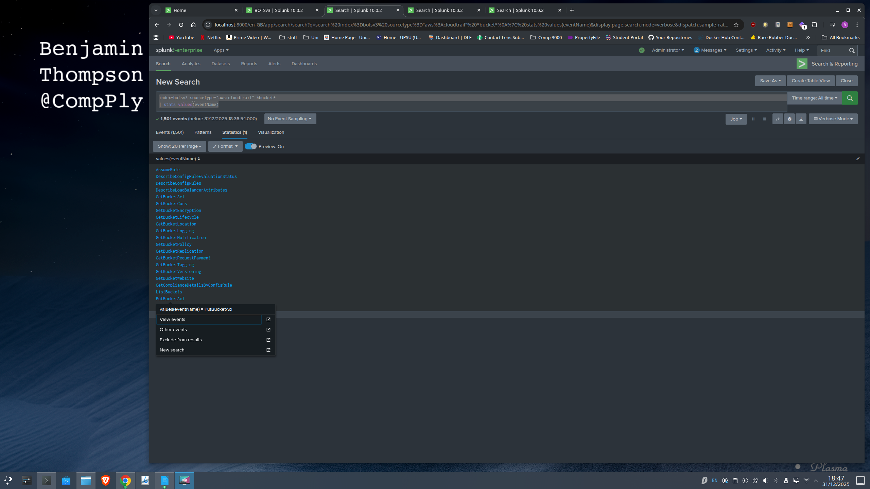Figure 13
To further isolate this event, structuring the results into a time-sequenced table to correlate the action with a unique transaction identifier and user identify .
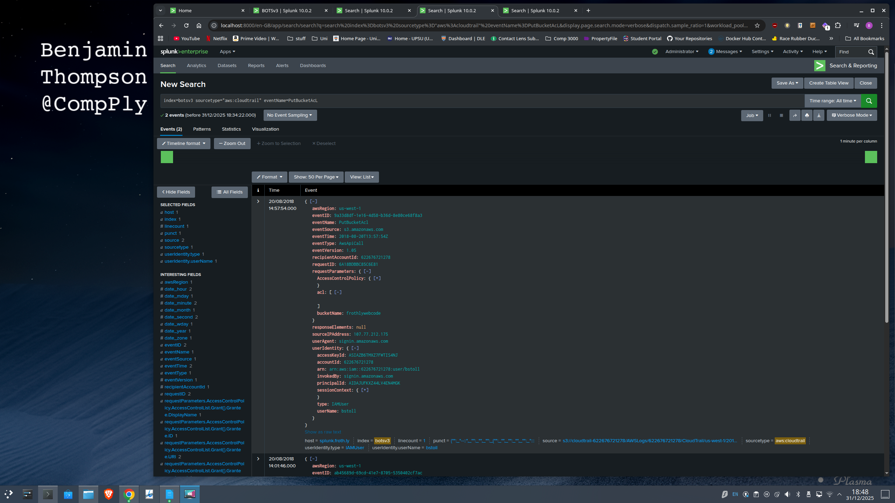Figure 14
index=botsv3 sourcetype=aws:cloudtrail eventName=PutBucketAcl
| table _time userIdentity.userName eventID requestParameters.bucketName
This analysis linked the event ID ab45689d-69cd-41e7-8705-5350402cf7ac to the user bstoll.
Furthermore, operationalising this search logic into a permanent dashboard [Figure Dash4] significantly enhances situational awareness by providing real-time visibility into critical configuration changes. In a SOC context, an unexpected PutBucketAcl event serves as a high-fidelity Indicator of Compromise (IoC). This dashboard enables Tier 2 analysts to rapidly triage alerts, verify Access Control List (ACL) parameters, and execute immediate containment protocols such as enforcing "S3 Block Public Access"before data exfiltration can occur. Strategically, this transition from ad-hoc forensic searching to continuous monitoring demonstrates Tier 3 (Detection Engineering) maturity, shifting the organisational posture from reactive analysis to the proactive assurance of infrastructure integrity.
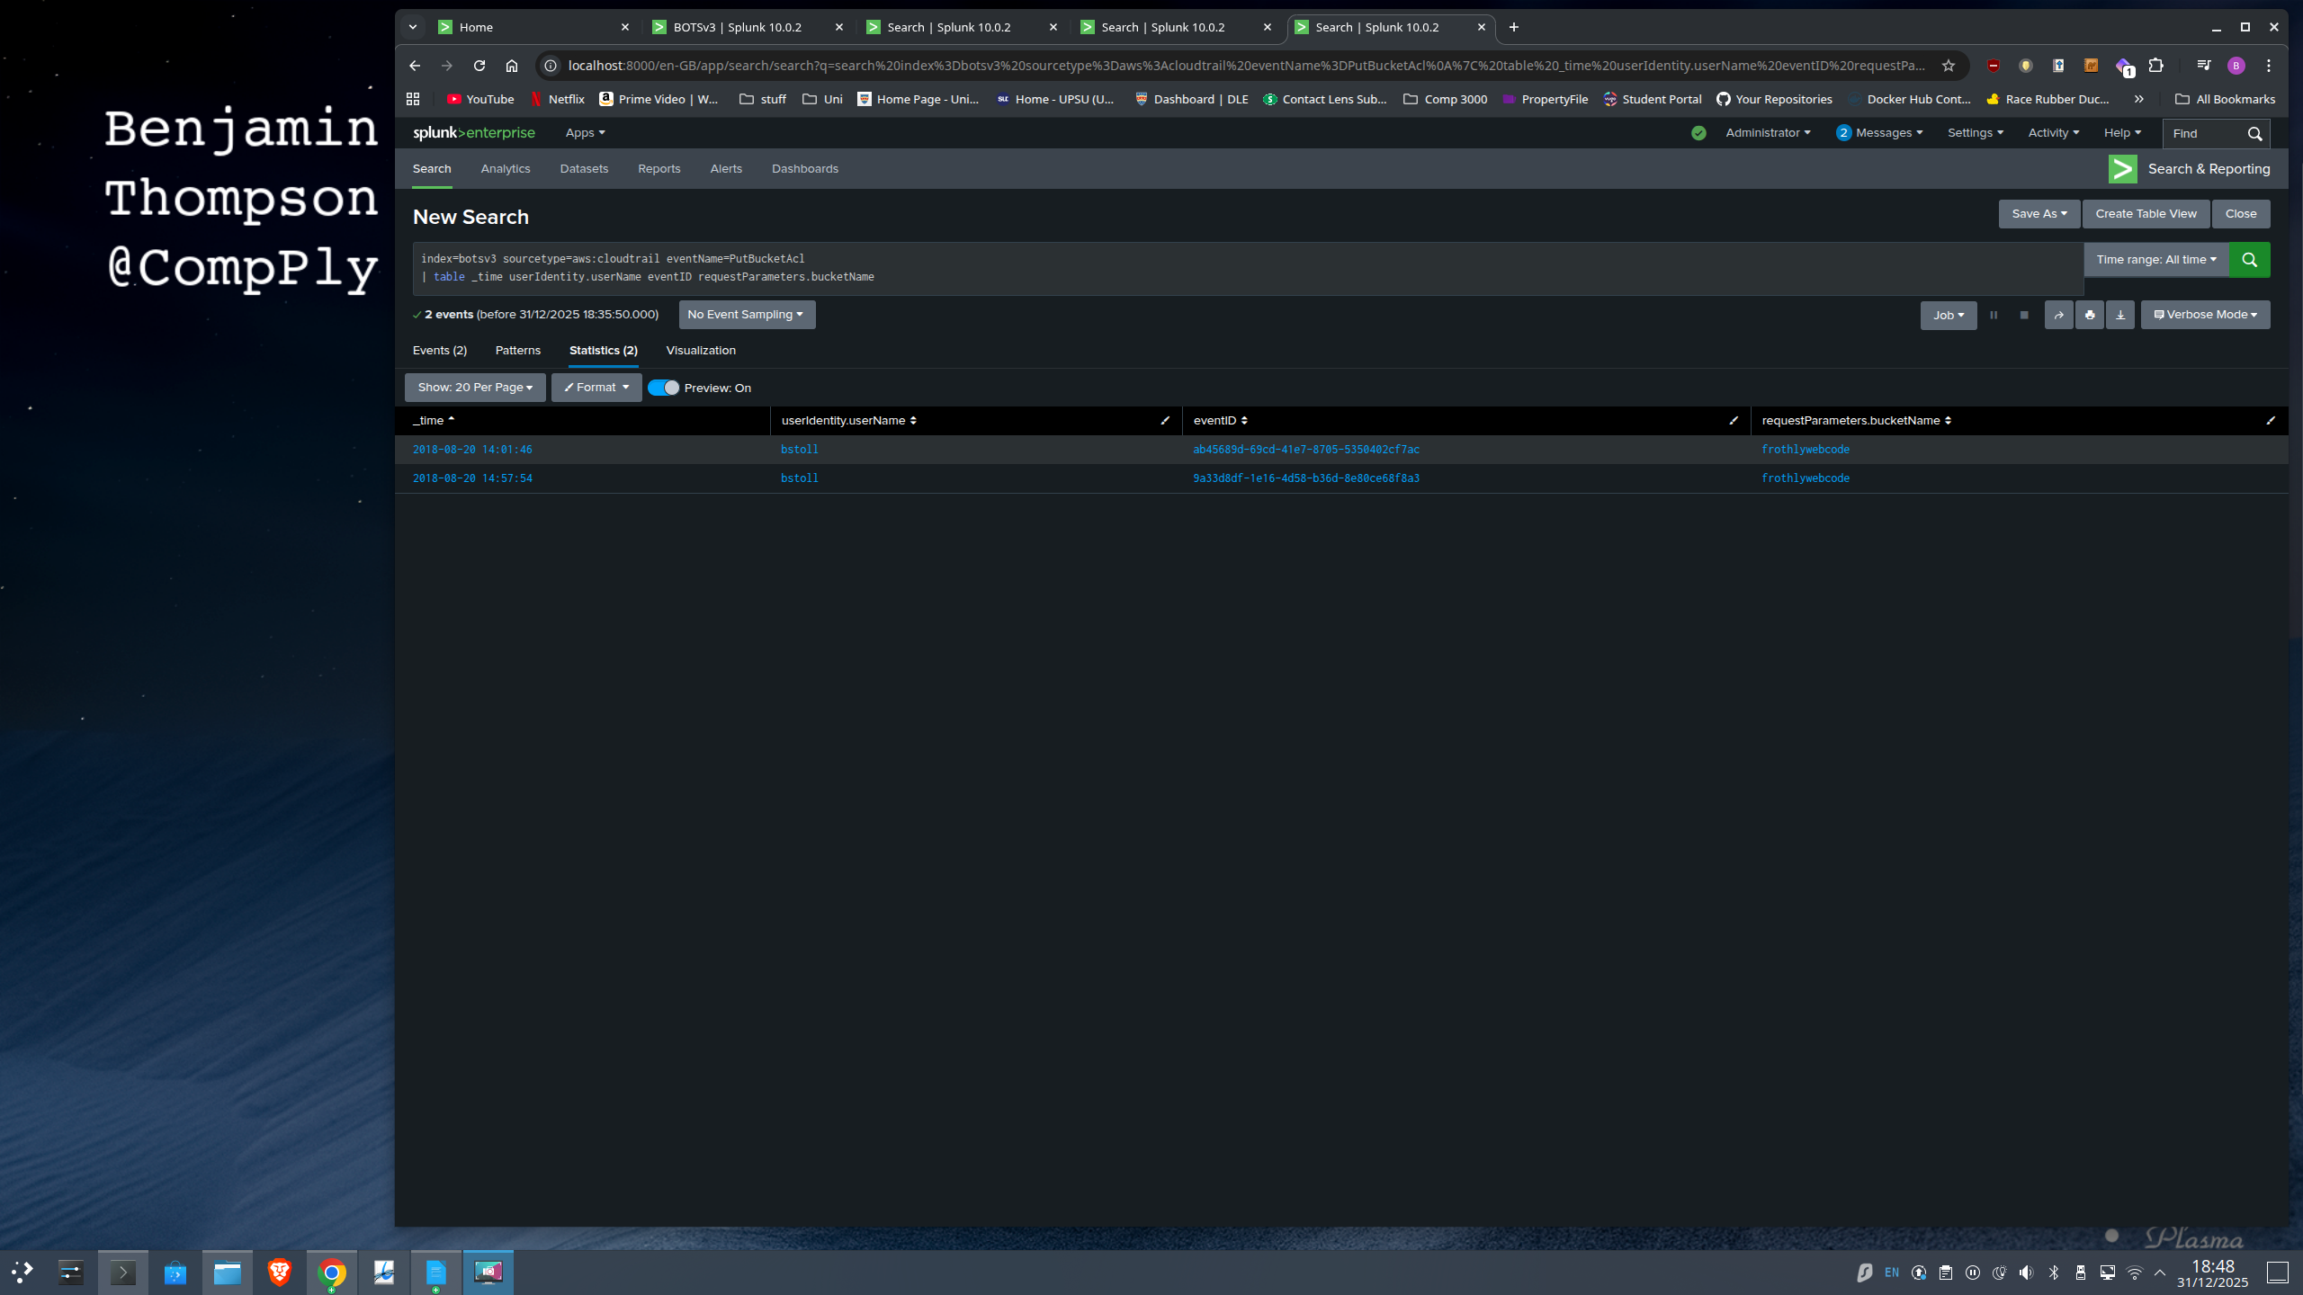Figure 15
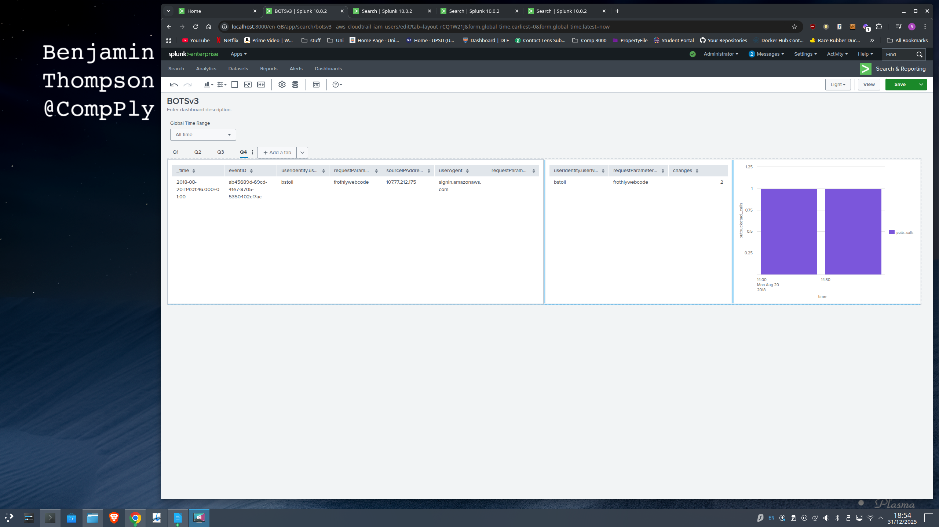Figure 16

4.5 Question 5: Bud's Username
To determine the username associated with the malicious S3 configuration change. The attribution was established by using the PutBucketAcl event identified in the previous step. (ab45689d-69cd-41e7-8705-5350402cf7ac), the investigation queried CloudTrail to surface the userIdentity structure. The logs confirmed the responsible user was bstoll.
index=botsv3 sourcetype=aws:cloudtrail eventID=ab45689d-69cd-41e7-8705-5350402cf7ac
| table _time eventName eventID userIdentity.userName userIdentity.arn
From a Security Operations Centre (SOC) perspective, anchoring identity attribution to a specific, immutable event ID is essential for establishing non-repudiation ensuring the incident response team can irrefutably prove who authorised the change. Crucially, this finding correlates with the risks identified in Q1 and Q2, where bstoll was flagged for API calls without MFA. This creates a comprehensive threat profile: a user bypassing authentication best practices while modifying critical infrastructure. Consequently, this warrants immediate escalation to the "Insider Threat" playbook (CISA, 2020).
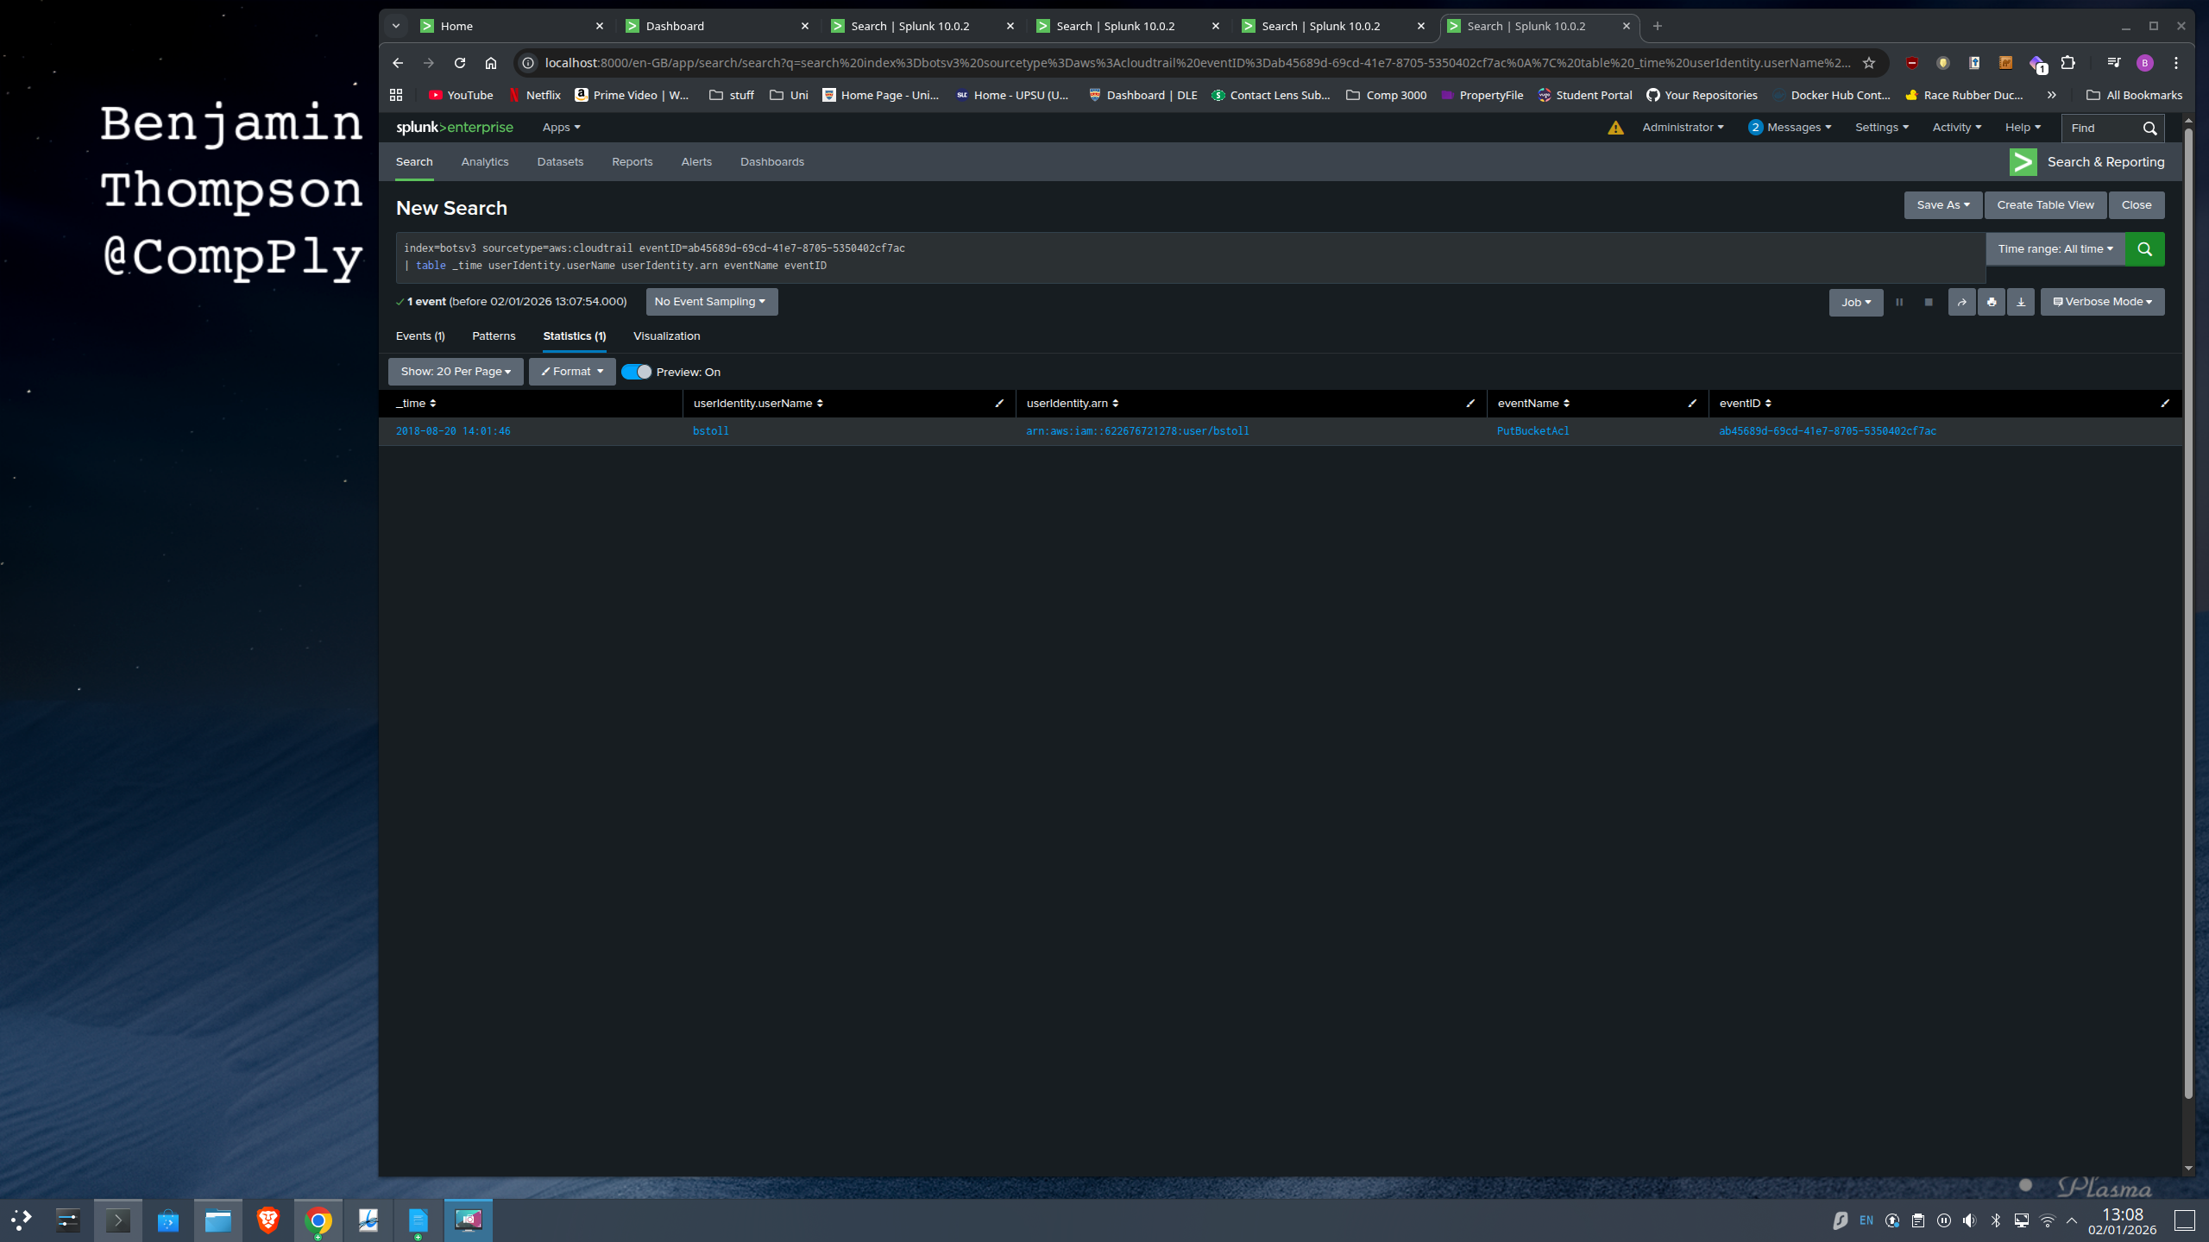Figure 17

4.6 Question 6: The Bucket Name
To identify the name of the S3 bucket that was made publicly accessible it would be esablished from the same CloudTrail event that enabled public access, ensuring the resource identification is directly linked to the misconfiguration Figure 17. Reviewing the raw JSON payload for the PutBucketAcl event revealed the bucketName parameter was populated with frothlywebcode.
Identifying the affected bucket provides the primary pivot for scoping and response. The naming convention frothlywebcode significantly escalates severity, implying the repository contains proprietary source code or web assets. For Tier 2 analysts, this shifts the focus from a generic leak to potential Intellectual Property (IP) theft, necessitating a correlation with aws:s3:accesslogs to determine if unauthorised retrieval occurred.
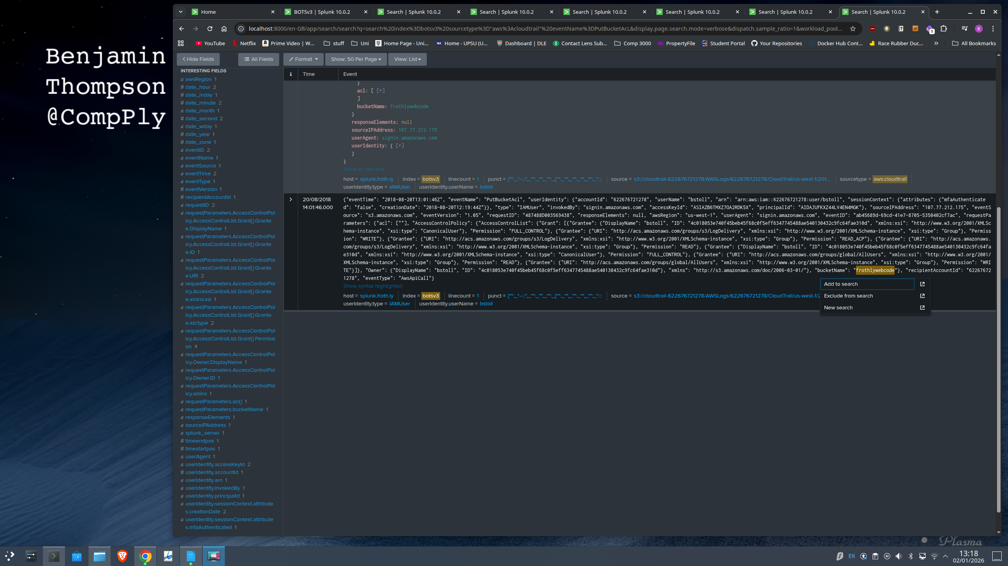Figure 18

4.7 Question 7: Data Exfiltration (File Upload)
Following the identification of the exposed bucket frothlywebcode he investigation sought to determine whether any files were successfully written to the bucket during the exposure window. While CloudTrail evidences any changes to (PutBucketAcl) but does not reliably confirm successful data uploads. So by changing the serach to S3 access logs (sourcetype=aws:s3:accesslogs), which record per-request activity and outcome codes. I filtered for successful upload behaviour by selecting PUT requests with HTTP 200 responses and restricting results to .txt objects:
index=botsv3 sourcetype="aws:s3:accesslogs" method=PUT http_status=200 *.txt
The resulting event shows the uploaded object in the key field, identifying the text file as OPEN_BUCKET_PLEASE_FIX.txt. The timestamp confirms this upload occurred immediately after the ACL change.
SOC Relevance & Critical Reflection: Confirming a successful upload transforms this event from a passive vulnerability to an active breach. Operationally, any unknown file found in a public bucket must be treated as hostile. The immediate workflow requires Tier 2 analysts to isolate the object for sandbox analysis, checking for webshells or Command & Control (C2) configurations (SentinelOne, 2025). Remediation must include verifying the integrity of the bucket’s entire contents to ensure no legitimate assets were overwritten (NIST, 2025).
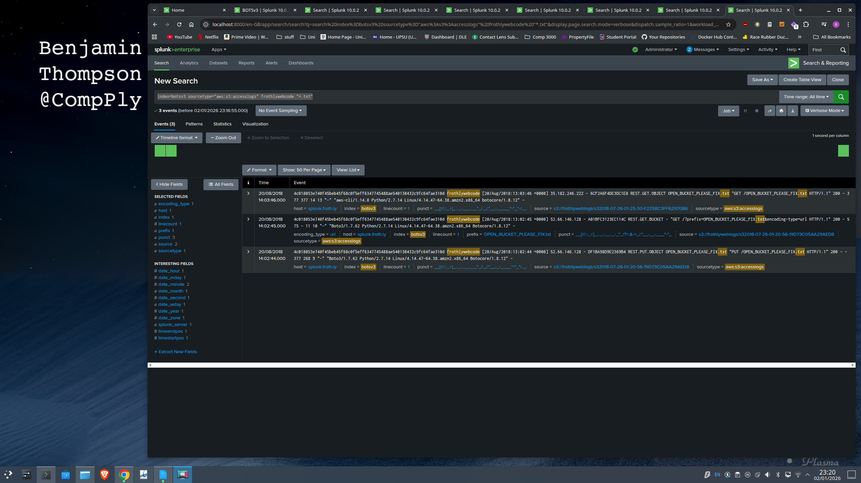Figure 19

4.8 Question 8: Endpoint Configuration Drift
To locate the endpoint running a different Windows edition, the search started by scoping out keywords to likely idenifty ata sources for operating system inventory. The keywords used were Windows, operating system, OS, edition, Enterprise, Pro, hostname, FQDN, and using the hint winhostmon and then queried the endpoint monitoring sourcetype to review what host inventory data was available:
index=botsv3 sourcetype=winhostmon
Reviewing the returned events showed that the source field distinguishes different host inventory categories, including operatingsystem (Figure S). I therefore refined the search to OS inventory records:
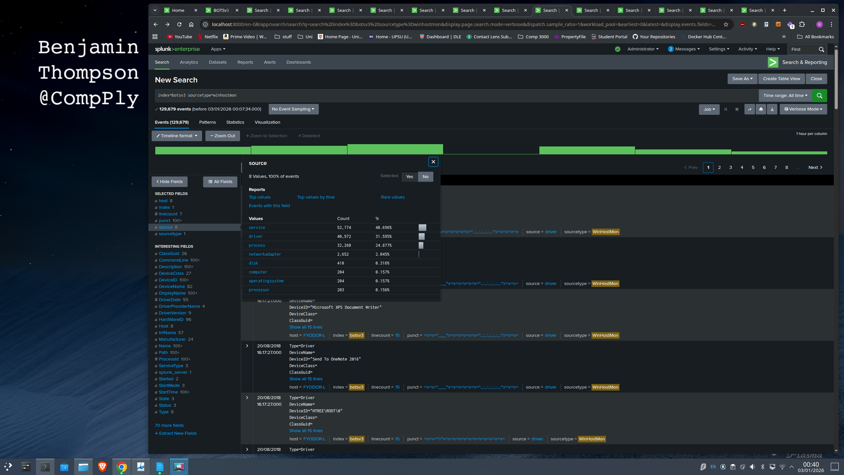Figure 20
index=botsv3 sourcetype=winhostmon source=operatingsystem
These events record the Windows edition in the OS field and the endpoint identifier in host. To compare endpoints and isolate the outlier, I generated a de-duplicated host-to-edition table:
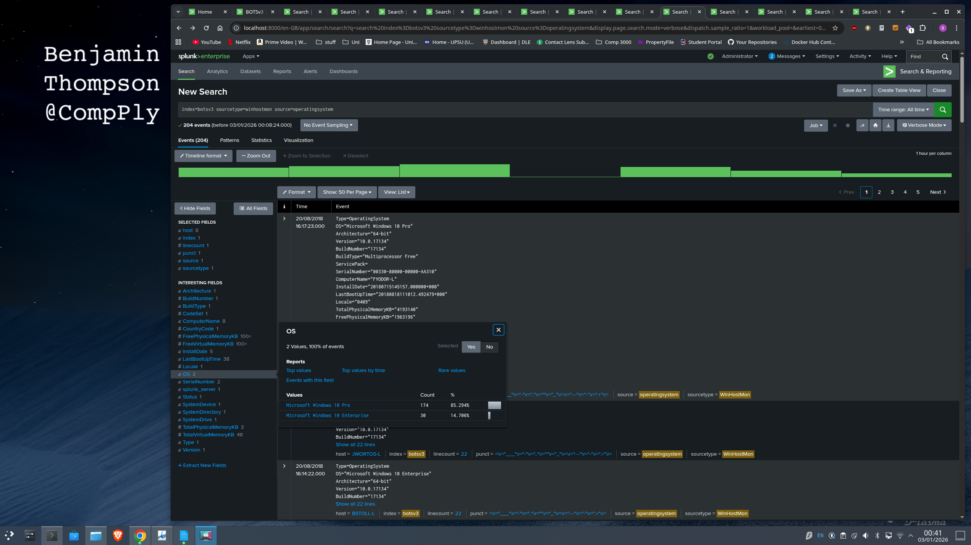Figure 21
index=botsv3 sourcetype=winhostmon
| dedup OS, host
| table OS, host
Finally to establish the endpoint we use the host seen in Q7 which was “host="splunk.froth.ly"” combining BSTOLL-L with .froth.ly gives us the answers BSTOLL-L.froth.ly.
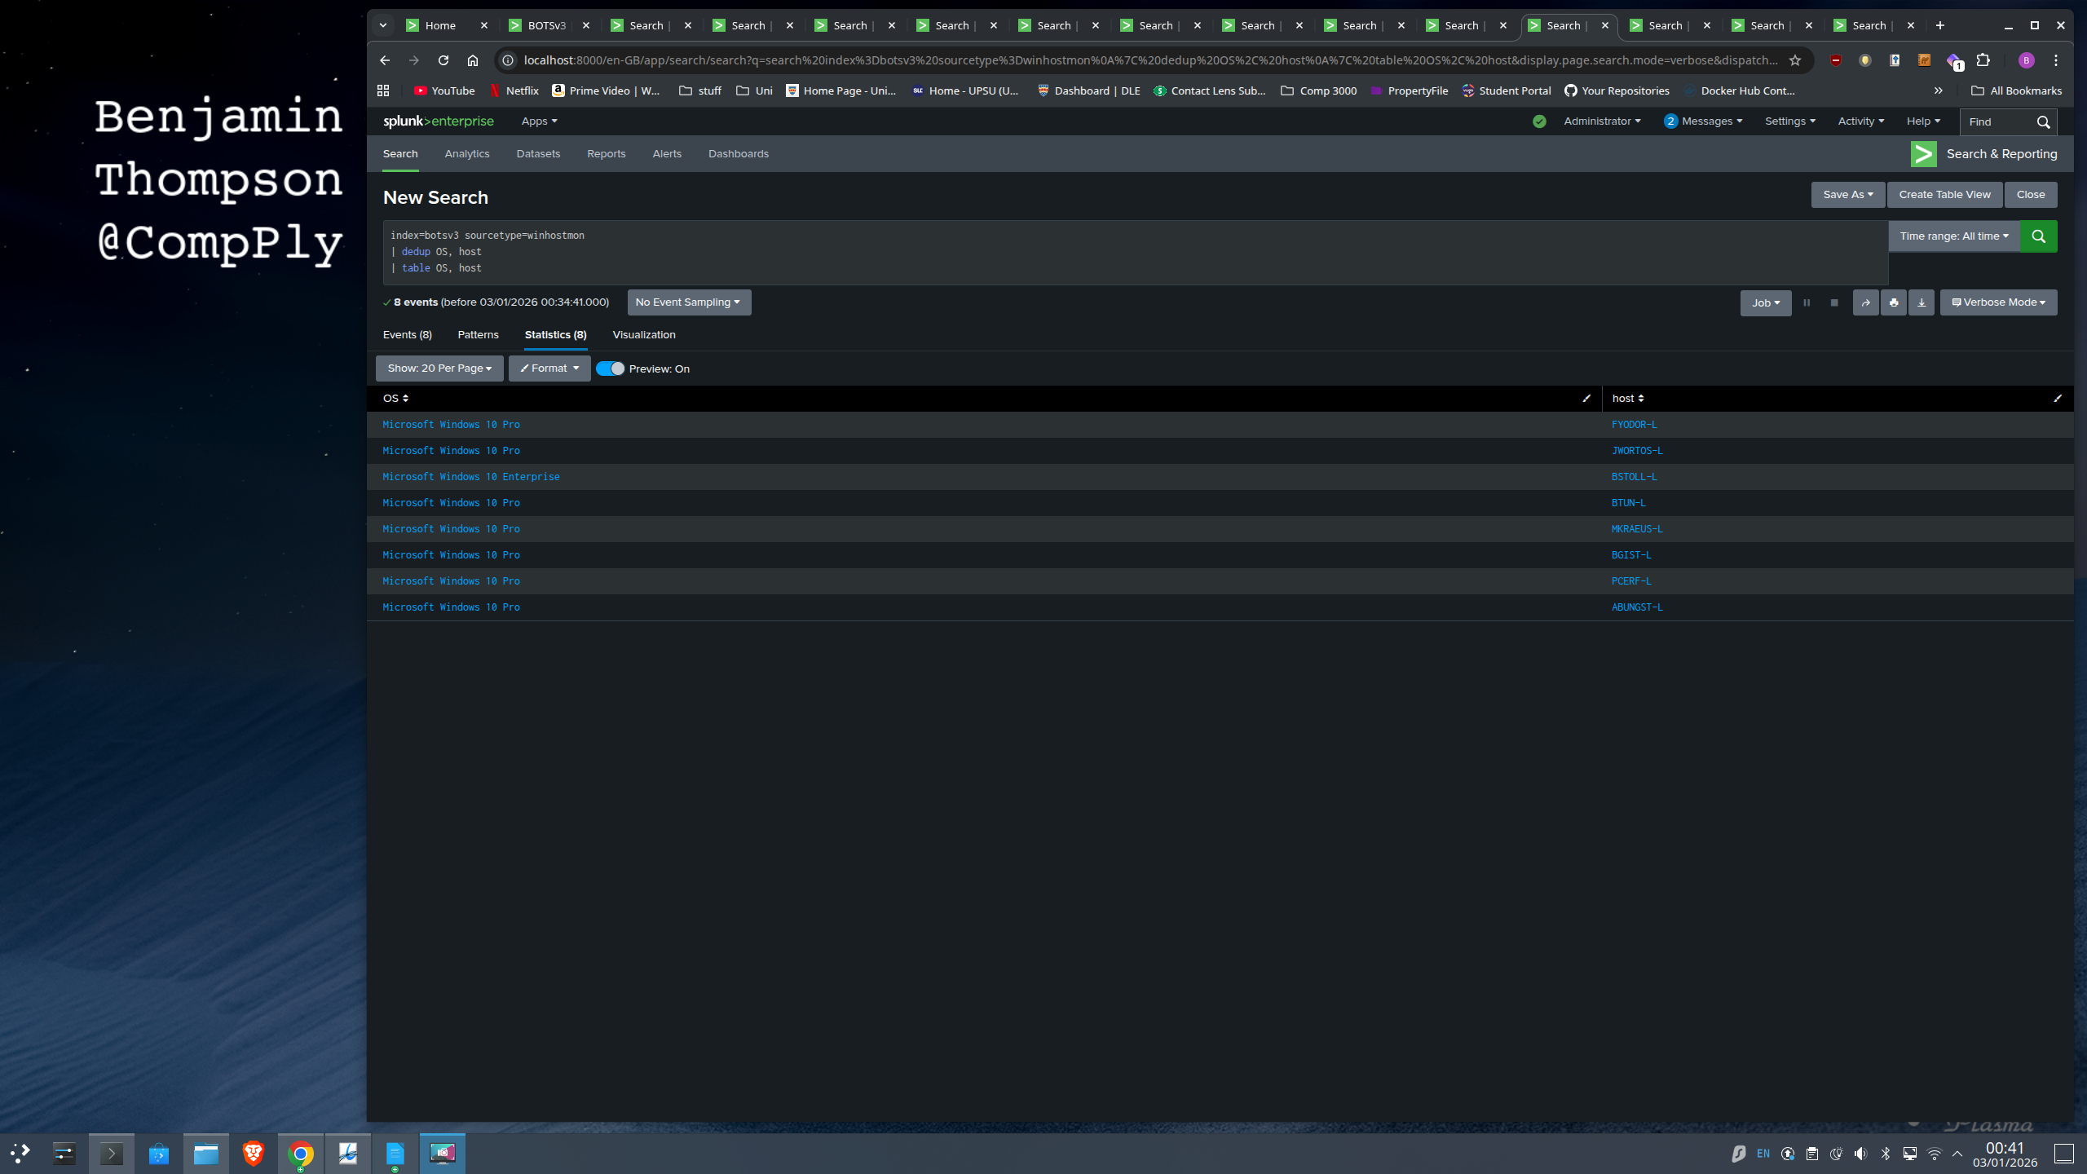Figure 22
From a SOC perspective, a non-standard operating system is a strong indicator of Configuration Drift or Shadow IT. When a device deviates from the agreed baseline (like running "Pro" in an "Enterprise" shop), it often lacks the centralized management and security controls Operational handling involves immediate verification: Tier 2 analysts must determine if this is a rogue "Bring-Your-Own-Device" (BYOD) asset. If the device is confirmed as unmanaged, it should be isolated immediately. To prevent this from happening again, the organization should implement Network Access Control (NAC), which automatically checks a device's health and OS version before allowing it to connect to the corporate network (NIST, 2020).
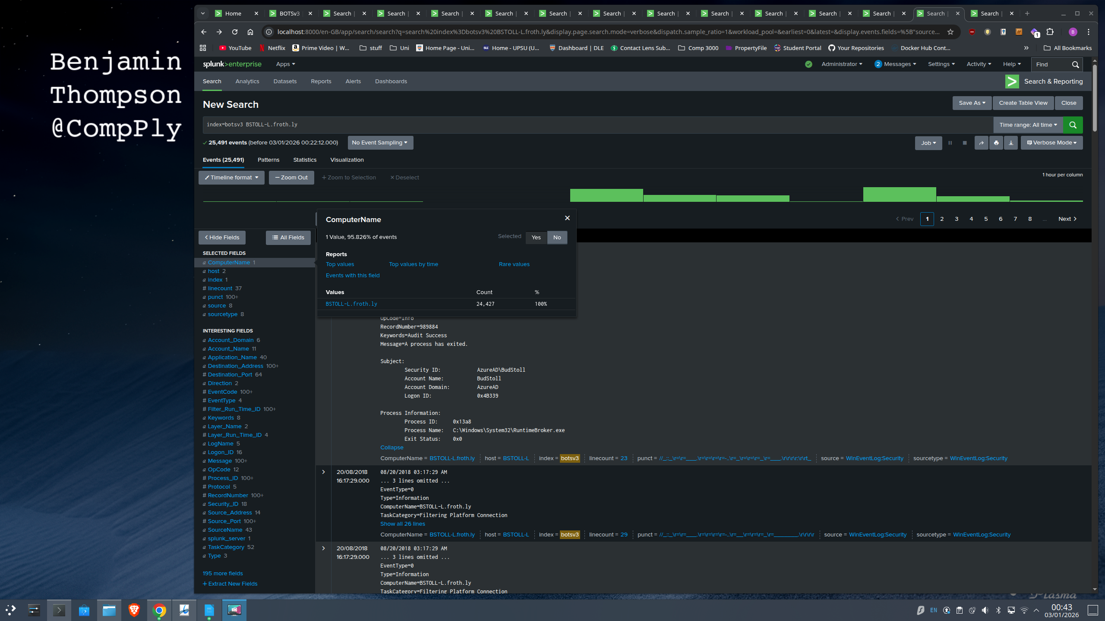Figure 23

5.Conclusion & Strategic Recommendations

5.1 Investigative Synthesis
This investigation evidences a high-impact cloud security failure arising from identity and configuration governance weaknesses, rather than a novel technical exploit. Correlation of AWS control-plane telemetry (CloudTrail) with supporting endpoint inventory data demonstrates that a named IAM principal (bstoll) initiated an S3 ACL change (PutBucketAcl) that created public exposure risk for a bucket associated with web assets. Subsequent S3 data-plane telemetry (S3 access logs) confirms successful object interaction during the exposure window, including an unauthorised text-object upload, indicating that the misconfiguration had tangible operational impact.
Importantly, this was not a visibility failure. The logging pipeline captured the relevant events with sufficient fidelity for attribution and scoping. The weakness was the absence of preventative guardrails capable of blocking high-risk actions at source. In parallel, the presence of a shared administrative account and inconsistent endpoint configuration signals reduce non-repudiation and complicate both detection and incident handling.

5.2 Strategic Implications
Two critical lessons follow from this incident. First, identity controls are the decisive boundary in cloud environments: where MFA enforcement and privilege governance are weak, valid credentials can be used to execute damaging administrative actions without triggering traditional perimeter controls. Second, baseline discipline matters: configuration drift (for example, divergent OS editions across a small fleet) should be treated as a control gap until ownership and policy coverage are verified, because it can indicate uneven hardening and monitoring.

5.3 Forward-Looking Recommendations
To shift from reactive detection to resilient prevention, the following priorities are recommended in line with NIST SP 800-61 recovery and post-incident improvement:
• Prevent public exposure by default: Enforce "S3 Block Public Access" at the account level and restrict ACL usage where feasible to eliminate the possibility of accidental exposure.
• Enforce MFA for privileged activity: Implement AWS Service Control Policies (SCPs) using MFA-present conditions to strictly deny sensitive actions (like PutBucketAcl) when MFA is not in place.
• Restore accountability: Remove shared credentials (web_admin), migrate to named accounts, and align permissions to strict least privilege.
• Reduce time-to-contain: Introduce SOAR-style automation to detect high-risk S3 permission changes and trigger immediate rollback and notification.
• Strengthen asset governance: Implement baseline validation controls (e.g., Network Access Control and configuration compliance reporting) so non-conforming endpoints are quarantined pending remediation.

